Union Island, Grenadines, Saint Vincent and the Grenadines
Called the 'Tahiti of the West Indies,' Union Island is a tiny volcanic jewel where kitesurfers skim turquoise shallows, sailors swap stories over rum punch, and the Tobago Cays wait just a short boat ride away.
⚓ Tender (no pier) · 🕒 Typical call: 6-8 hrs · 💵 USD & XCD accepted · 🗣️ English (Vincentian Creole) · 🌊 Top kitesurfing destination
✍️ MY DAY IN PORT (FILL IN)
Ship / Date
In port | arrive ______ · all aboard ______
Booked excursion
Notes / meeting point
GETTING ASHORE
- Docking: Tender to Clifton Jetty — no cruise pier
- Walk to center: 0 min — tender drops you in Clifton village
- Best For: Tobago Cays day trip, kitesurfing, Happy Island bar
- Don't Miss: Happy Island — a bar built on a pile of conch shells in the harbour
GETTING AROUND
- 🚕 Taxi: Negotiated — ~$30–60 USD for island tour — Taxis are scarce informal minivans or private cars; drivers often double as guides. Always agree on the full fare before
- 📱 Rideshare: ❌ not available
TOP THINGS TO DO
- Tobago Cays Marine Park — The standout excursion from Union Island — a catamaran day sail to five uninhabited keys, swim with green sea turtles, snorkel…
- Happy Island Bar — A man-made island built entirely from discarded conch shells by a local named Janti.
- Kitesurfing at JT Pro Center — Union Island is one of the Caribbean's top kitesurfing spots.
- Chatham Bay Escape — Union Island's most secluded beach — a crescent of golden sand on the leeward west coast.
- Fort Hill Hike & Views — A 15–20 minute uphill walk from the Clifton jetty takes you to the ruins of a 17th-century fort offering 360-degree views of the…
BEST WALKS
- Clifton Harbour Stroll: 0.5 mi · 20 min · Easy · Flat — From the tender jetty, walk the colorful single-street town past fruit stalls, boutiques, and the…
- Fort Hill Lookout: 0.8 mi · 35 min RT · Moderate · Uphill — Head uphill from central Clifton to the old fort ruins above town.
cruiseports.org/union-island-grenadines · Confirm terminal & all-aboard time with your ship

Union Island, Grenadines, Saint Vincent and the Grenadines — Port Map
Red = walkable sights · Amber = excursions farther out · P = cruise terminal
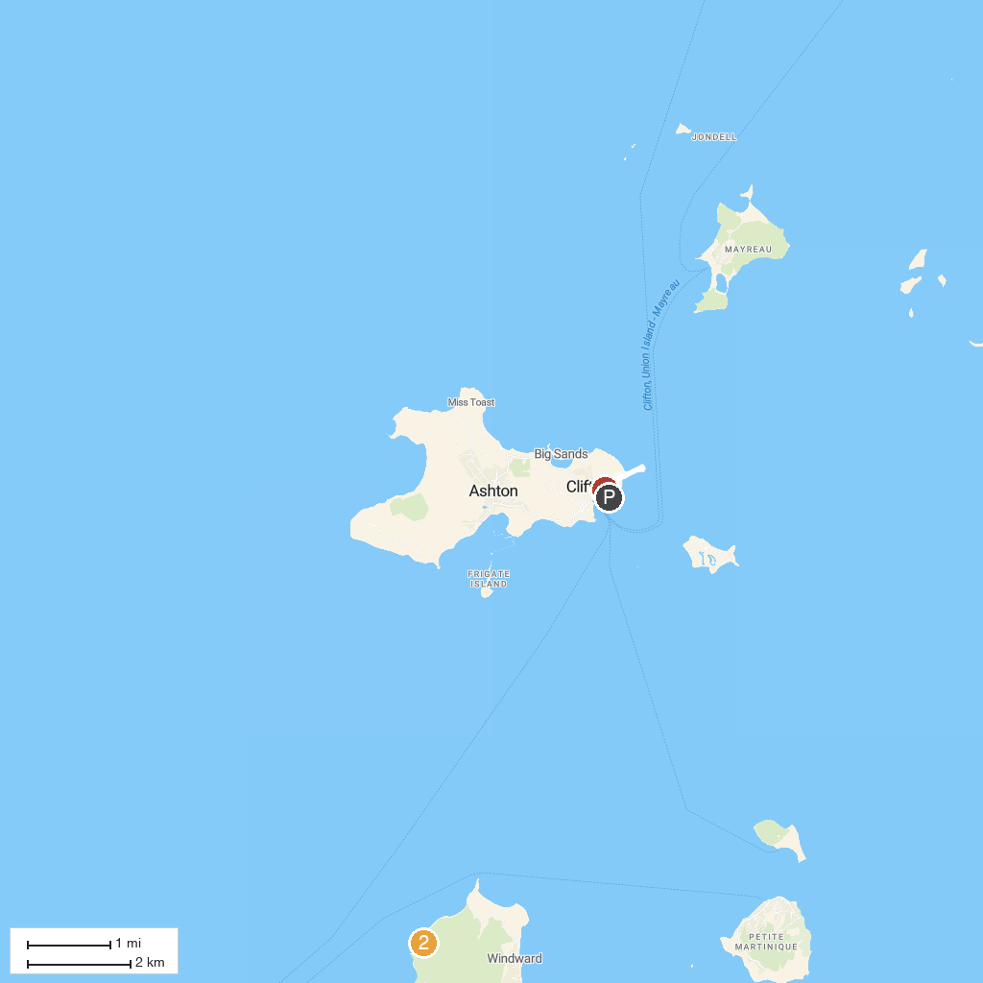
MAP KEY
1. Kiteboarding Cruise - Caribbean | 3. Carriacou Museum
2. Anse La Roche Bay
P. Cruise port / terminal
Map © MapTiler © OpenStreetMap contributors · cruiseports.org

