Valdez, Alaska, USA
The "Little Switzerland of Alaska" sits at the head of a deep fjord in Prince William Sound, ringed by glaciated peaks and roaring waterfalls. It's a working Alaskan town with minimal crowds and maximum scenery.
⚓ Pier (docked) · 🕒 Typical call: 8-10 hrs · 💵 USD · 🗣️ English · 🏔️ Glaciers & wildlife
✍️ MY DAY IN PORT (FILL IN)
Ship / Date
In port | arrive ______ · all aboard ______
Booked excursion
Notes / meeting point
GETTING ASHORE
- Docking: Pier — Kelsey Dock (downtown) or Container Terminal (~1.5 mi from center)
- Walk to center: Steps from Kelsey Dock; ~30 min walk or shuttle from Container Terminal
- Best For: Glacier cruises, kayaking, earthquake history, wildlife
- Don't Miss: Columbia Glacier boat tour — one of North America's great tidewater glaciers
GETTING AROUND
- 🚕 Taxi: – in town — Valdez Yellow Cars (907-835-2500) must be called in advance — no street hailing. Expect a 15–20 minute wait on cruise da
TOP THINGS TO DO
- Columbia Glacier Marine Cruise — One of North America's largest and fastest-retreating tidewater glaciers.
- Sea Kayaking in Prince William Sound — Valdez is a world-class kayaking destination.
- Keystone Canyon & Waterfalls — A dramatic canyon just outside town with towering walls and spectacular falls — Bridal Veil Falls and Horsetail Falls.
- Valdez Museum & Earthquake History — The 9.2-magnitude 1964 Good Friday Earthquake leveled the original Valdez and triggered a massive tsunami.
- Solomon Gulch Hatchery & Wildlife Viewing — Millions of pink and coho salmon return here in July–August, drawing bald eagles, sea lions, harbor seals, and black bears.
BEST WALKS
- Downtown Harbor Loop: ~1 mile | Easy | 30 min — From Kelsey Dock, stroll along the small boat harbor to the Valdez Museum on Egan Drive, then…
- Dock Point Trail: 1-mile loop | Easy | 45 min — A beautiful loop trail at the edge of the harbor offering views of the bay, salt marshes, and…
- Old Valdez Town Site: ~4 miles from dock | Moderate (requires taxi/tour) | 1 hr — The haunting foundations of original Valdez, destroyed by the 1964 earthquake.
WEATHER · DAYLIGHT · MONEY
Month | High °F | Low °F | Rainy days
May | 53 | 40 | None
Jul | 62 | 49 | None
Sep | 53 | 42 | None
Daylight: May 4:58AM–10:27PM · Jul 4:39AM–11:01PM · Sep 7:13AM–8:05PM
cruiseports.org/valdez · Confirm terminal & all-aboard time with your ship

Valdez, Alaska, USA — Port Map
Red = walkable sights · Amber = excursions farther out · P = cruise terminal
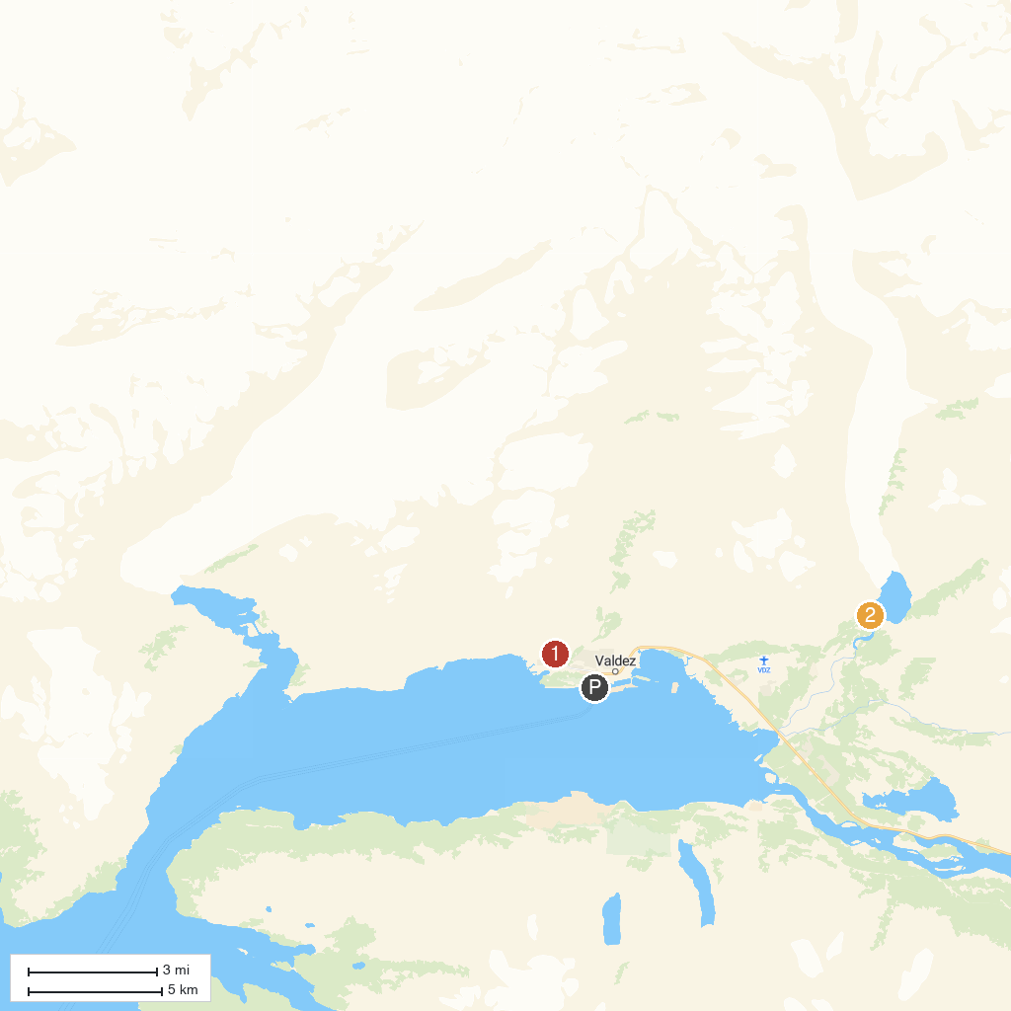
MAP KEY
1. Shoup Bay Trail Park | 2. Valdez Glacier Lake
P. Cruise port / terminal
Map © MapTiler © OpenStreetMap contributors · cruiseports.org

