Valparaíso, Valparaíso Region, Chile
A riot of color cascading down forty-two hills above the Pacific, Valparaíso pairs UNESCO World Heritage streetscapes and rattling ascensores with easy access to Casablanca Valley wines and the capital, Santiago.
⚓ Docked (cruise terminal) · 🕒 Typical call: 8-10 hrs · 💵 Chilean Peso (cards widely accepted) · 🗣️ Spanish
✍️ MY DAY IN PORT (FILL IN)
Ship / Date
In port | arrive ______ · all aboard ______
Booked excursion
Notes / meeting point
GETTING ASHORE
- Docking: Berthed at Valparaíso Terminal de Pasajeros (VTP); free shuttle to Muelle Prat city-center drop
- Walk to center: ~10 min from Muelle Prat to Plaza Sotomayor; shuttle included
- Best For: Street art & funiculars, Pablo Neruda museums, Casablanca wine, Santiago day trips
- Don't Miss: Riding Ascensor Concepción and the view from Cerro Alegre
GETTING AROUND
- 🚕 Taxi: CLP 500–2,000 (~$0.60–2.50 USD) within city — Yellow taxis are metered; confirm fare before departing. Shared colectivos (fixed-route shared taxis) are very cheap at
- 📱 Rideshare: ✅ Uber, DiDi, Cabify
TOP THINGS TO DO
- Cerro Alegre & Cerro Concepción Walking Tour — Stroll the UNESCO-listed hillside neighborhoods where pastel houses, open-air murals, and café-lined lanes reward every turn.
- La Sebastiana — Pablo Neruda's House — The Nobel laureate's eccentrically decorated clifftop home is now a museum.
- Casablanca Valley Wine Tasting — Chile's premier cool-climate wine zone sits just 30 minutes inland.
- Santiago City Day Trip — Chile's cosmopolitan capital rewards a long day: Plaza de Armas, La Moneda Palace, Mercado Central's seafood hall, and the…
- Cerro San Cristóbal Funicular, Santiago — For those heading to Santiago, the 1925 funicular up Cerro San Cristóbal delivers panoramic city-and-Andes vistas.
BEST WALKS
- Muelle Prat to Cerro Alegre Loop: 2.5 km · 1.5-2 hrs · Moderate (steep ascents) — Start at Muelle Prat on the waterfront, cross Plaza Sotomayor, and take Ascensor El Peral up to…
- Waterfront & Fish Market Stroll: 1.5 km · 45 min · Easy (flat) — An easy flat walk along the Avenida Errázuriz waterfront from Muelle Prat past the sea lion colony…
WEATHER · DAYLIGHT · MONEY
Month | High °F | Low °F | Rainy days
May | 62 | 53 | 4
Jul | 58 | 49 | 6
Sep | 59 | 50 | 3
Daylight: May 7:30AM–5:54PM · Jul 7:47AM–5:57PM · Sep 7:45AM–7:38PM
cruiseports.org/valparaiso-santiago · Confirm terminal & all-aboard time with your ship

Valparaíso, Valparaíso Region, Chile — Port Map
Red = walkable sights · Amber = excursions farther out · P = cruise terminal
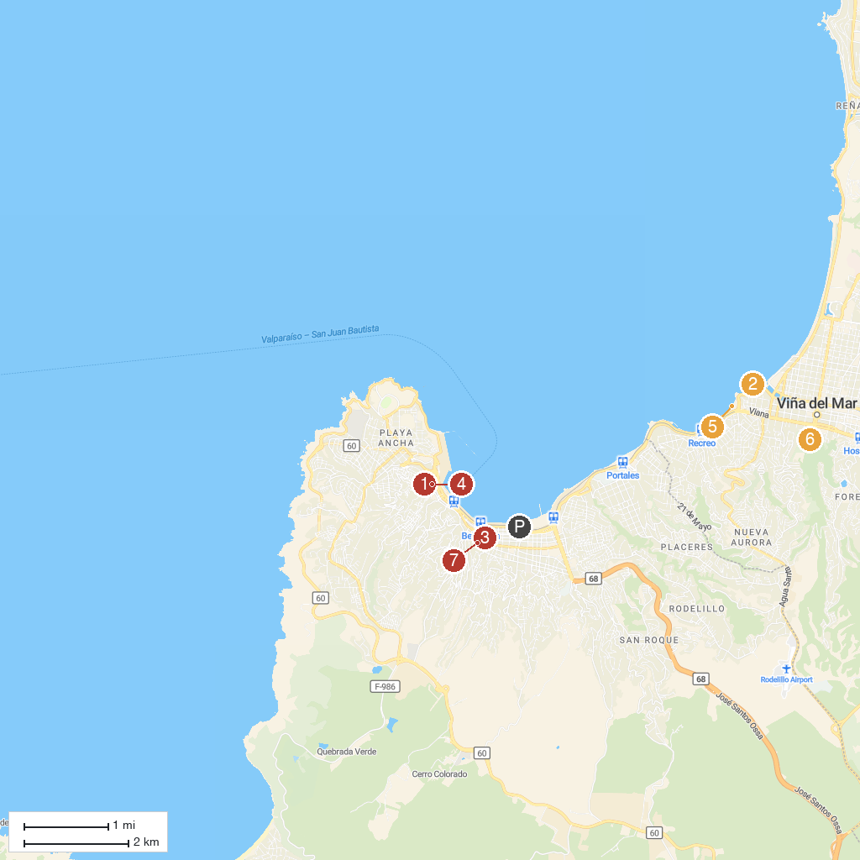
MAP KEY
1. Iglesia de la Matriz | 5. Playa Caleta Abarca
2. Wulff Castle | 6. Quinta Vergara
3. Simón Bolívar Square | 7. Museo de Historia Natural de Valparaíso
4. Plaza Echaurren
P. Cruise port / terminal
Map © MapTiler © OpenStreetMap contributors · cruiseports.org

