Vancouver, British Columbia, Canada
A stunning natural harbour framed by snow-capped Coast Mountains, Vancouver is one of the world's great cruise homeports — and a city well worth a full day of exploration before or after your voyage.
⚓ Docked (pier) · 🕒 Typical call: homeport / 8+ hrs · 💵 Canadian Dollar (CAD) · 🗣️ English
✍️ MY DAY IN PORT (FILL IN)
Ship / Date
In port | arrive ______ · all aboard ______
Booked excursion
Notes / meeting point
GETTING ASHORE
- Docking: Canada Place terminal — downtown waterfront, 3 berths, no tender ever
- Walk to centre: 5 min — you're already in downtown; Gastown is 10 min on foot
- Best For: Urban exploring, foodie scene, day trips to Whistler or Victoria
- Don't Miss: Lions Gate Bridge sail-away & Stanley Park seawall
GETTING AROUND
- 🚕 Taxi: CAD $15 — Taxis are readily available at Canada Place. A short ride to downtown hotels costs roughly CAD $15; zone-based flat fare
- 📱 Rideshare: ✅ Uber, Lyft
- 🚌 Hop-on hop-off: ✅ Hop-on hop-off
TOP THINGS TO DO
- Stanley Park & Seawall — Walk or cycle the 8.8 km paved seawall around Vancouver's waterfront Stanley Park.
- Capilano Suspension Bridge — A 137-metre swaying bridge 70 metres above the Capilano River canyon in North Vancouver's old-growth forest.
- Whistler Day Trip — Canada's most celebrated mountain resort is 120 km north via the Sea-to-Sky Highway — consistently ranked one of the world's most…
- Granville Island Public Market — A former industrial peninsula turned vibrant food and arts hub on False Creek.
- Gastown Walking Tour — Vancouver's oldest neighbourhood, 10 minutes on foot from Canada Place.
BEST WALKS
- Coal Harbour Seawall to Stanley Park: 2.5 km · ~30 min · Easy · Flat paved path — Stroll west from Canada Place along the Coal Harbour waterfront past float-plane terminals, rows of…
- Gastown & Chinatown Loop: 3.5 km · ~50 min · Easy — Head east from Canada Place into historic Gastown — Water Street Steam Clock, Maple Tree Square…
WEATHER · DAYLIGHT · MONEY
Month | High °F | Low °F | Rainy days
May | 62 | 49 | 9
Jul | 72 | 59 | 5
Sep | 65 | 54 | 12
Daylight: May 5:29AM–8:49PM · Jul 5:24AM–9:12PM · Sep 6:49AM–7:24PM
ESSENTIAL TRAVEL QUALIFICATIONS
Canada Place airport connection: Canada Line at Waterfront. Adult fare CAD $3.50 (1 zone) / $5.10 (2 zones); applicable YVR-origin AddFare +$6.50 (checked 3 October 2026). Confirm zones/time/payment rules.
cruiseports.org/vancouver · Confirm terminal & all-aboard time with your ship

Vancouver, British Columbia, Canada — Port Map
Red = walkable sights · Amber = excursions farther out · P = cruise terminal
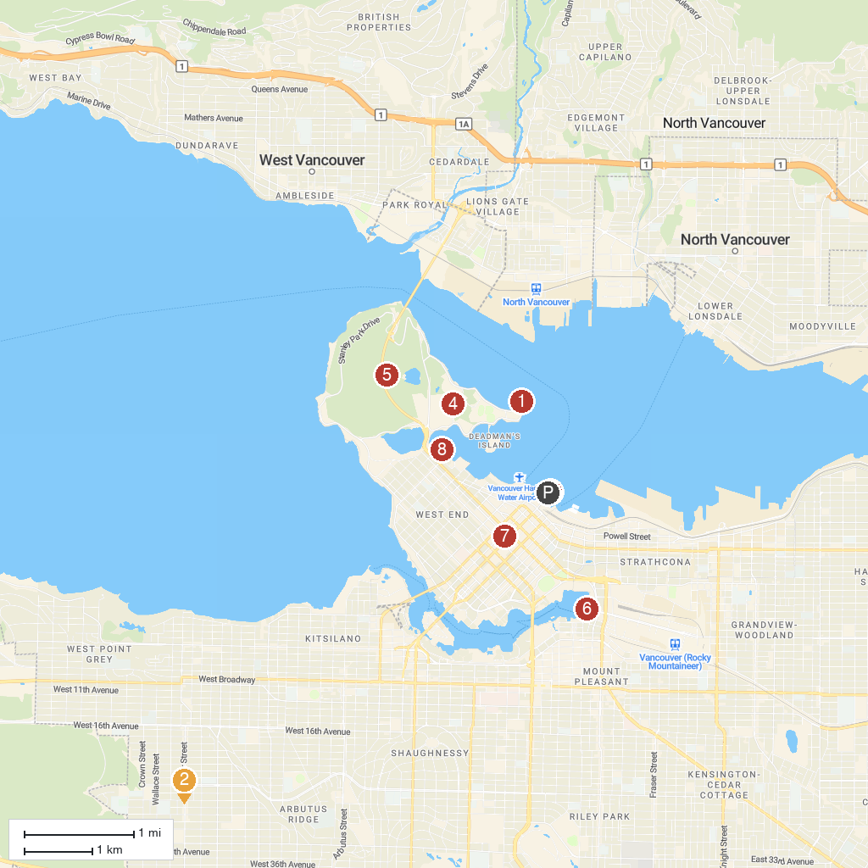
MAP KEY
1. Brockton Point Lighthouse | 5. Stanley Park
2. Deering Island Park | 6. Science World
3. Canada Place | 7. Vancouver Art Gallery
4. Vancouver Aquarium | 8. Harbour Cruises Ltd
P. Cruise port / terminal
Map © MapTiler © OpenStreetMap contributors · cruiseports.org

