Vancouver, Washington, USA
Perched on the north bank of the Columbia River, Vancouver, Washington rewards river cruisers with a living piece of American frontier history at Fort Vancouver, a revitalized waterfront, and the energy of Portland just across the bridge.
⚓ Docked (Columbia River waterfront) · 🕒 Typical call: 6-8 hrs · 💵 USD · 🗣️ English · 🌲 Pacific Northwest
✍️ MY DAY IN PORT (FILL IN)
Ship / Date
In port | arrive ______ · all aboard ______
Booked excursion
Notes / meeting point
GETTING ASHORE
- Docking: Docked at Port of Vancouver Terminal 1 on the Columbia River waterfront
- Walk to center: Downtown Vancouver is about 10–15 min on foot from the pier
- Best For: American frontier history, Columbia River scenery, and Portland day-tripping
- Don't Miss: Fort Vancouver National Historic Site and the Columbia River Renaissance Trail
GETTING AROUND
- 🚕 Taxi: $12–$15 — Taxis are available at the Port of Vancouver USA (Terminal 1). The ride to downtown Vancouver takes approximately 5 minu
- 📱 Rideshare: ✅ Uber, Lyft
TOP THINGS TO DO
- Fort Vancouver National Historic Site — The reconstructed Hudson's Bay Company fur-trade fort is one of the most significant historic sites in the Pacific Northwest.
- Columbia River Renaissance Trail — This paved waterfront trail stretches several miles along the Columbia River offering views of the river, the Interstate Bridge…
- Portland Day Trip — Portland's Pearl District, Powell's Books, the Portland Saturday Market (weekends), and a thriving food scene are all within 15…
- Officers' Row & Pearson Field — Adjacent to Fort Vancouver, Officers' Row features 21 beautifully preserved historic homes from the army-post era.
- Vancouver Waterfront Dining — The redeveloped Columbia River Waterfront district offers restaurants, tap houses, and cafes within a short walk of the docks.
BEST WALKS
- Waterfront to Downtown Loop: 2 miles | 45–60 min | Easy | Flat paved trail — Follow the Waterfront Renaissance Trail east toward Vancouver Waterfront Park, then cut north to…
- Fort Vancouver Walk: 3 miles round-trip | 1.5 hrs | Easy | Mostly flat — Follow the Renaissance Trail east and cross the pedestrian Land Bridge inland to Fort Vancouver…
WEATHER · DAYLIGHT · MONEY
Month | High °F | Low °F | Rainy days
May | 62 | 49 | 9
Jul | 72 | 59 | 5
Sep | 65 | 54 | 12
Daylight: May 5:29AM–8:49PM · Jul 5:24AM–9:12PM · Sep 6:49AM–7:24PM
cruiseports.org/vancouver-wa · Confirm terminal & all-aboard time with your ship

Vancouver, Washington, USA — Port Map
Red = walkable sights · Amber = excursions farther out · P = cruise terminal
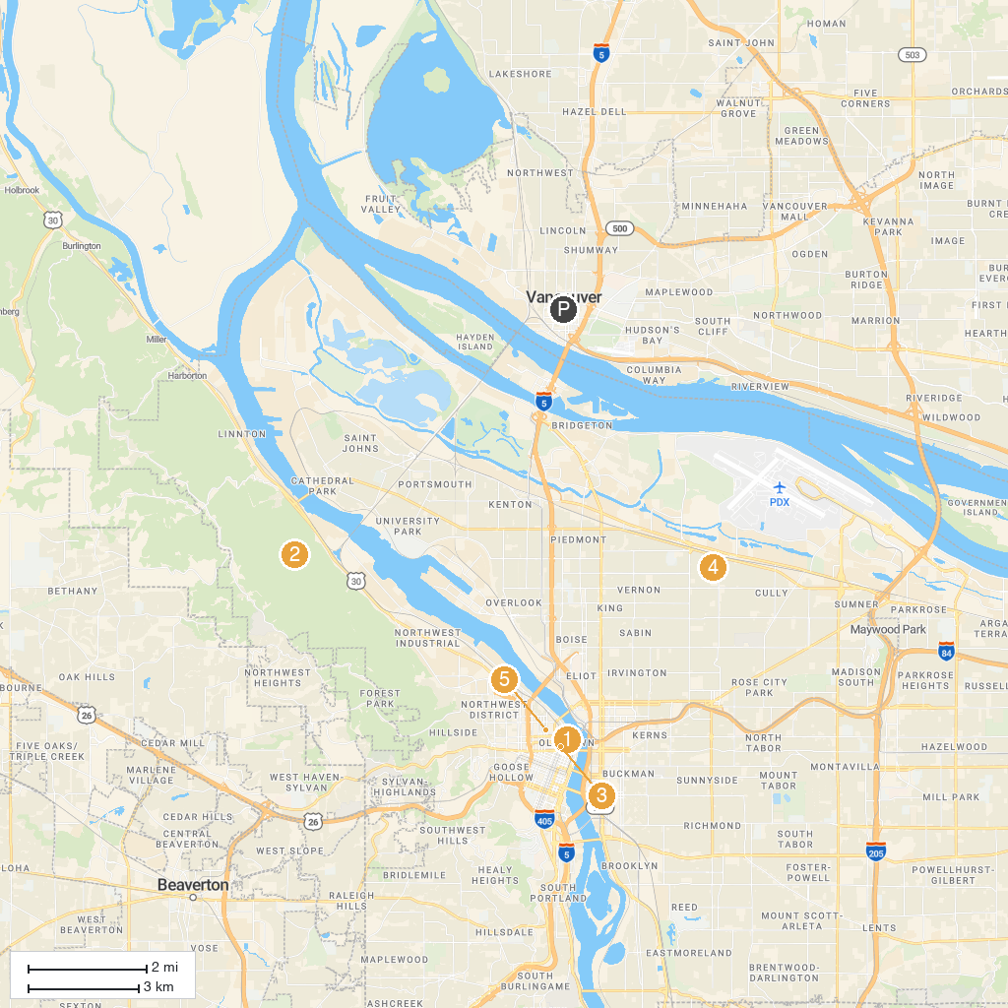
MAP KEY
1. Portland Art Museum | 5. Forest Park
2. Oregon Zoo | 6. Ground Kontrol Classic Arcade and Bar
3. Lan Su Chinese Garden | 7. Off-Leash Area of Fernhill Park
4. International Rose Test Garden | 8. Ecotrust Building
P. Cruise port / terminal
Map © MapTiler © OpenStreetMap contributors · cruiseports.org

