Venice, Veneto, Italy
No roads, no cars — just 118 islands stitched together by bridges. Your actual arrival port and terminal shape the visit: a cruise marketed for Venice may require a transfer from a different port. Check your cruise documents before planning the day.
⚓ Confirm actual itinerary port and terminal · 🕒 Typical call: 8–12 hrs · 💶 Euro (EUR) · 🗣️ Italian · English widely spoken
✍️ MY DAY IN PORT (FILL IN)
Ship / Date
In port | arrive ______ · all aboard ______
Booked excursion
Notes / meeting point
GETTING ASHORE
- Docking: Check cruise documents: Venice-area terminal, Ravenna/Porto Corsini or Trieste are not interchangeable
- To St. Mark's: Depends on actual port, terminal and booked transfer; verify both directions
- Best For: History · Art · Canals · Unique island life
- Don't Miss: Piazza San Marco early + Rialto Market + a cicchetti crawl
GETTING AROUND
- 🚕 Taxi: €60–€75 — Private motorboat from the cruise pier to your hotel or San Marco in about 20 minutes. Base fare ~€15 plus ~€2/min; nigh
- 📱 Rideshare: ✅ Uber
TOP THINGS TO DO
- St. Mark's Square & Basilica — The gilded Byzantine Basilica di San Marco, the soaring Campanile bell tower (elevator + sweeping lagoon views), and the Doge's…
- Doge's Palace & Bridge of Sighs — The seat of Venetian power for a thousand years — gilded halls, a vast armory, the Grand Council chamber, and the infamous prison…
- Gondola Ride or Traghetto Crossing — A private gondola runs €80–100 for 30 min (more at night) — negotiate before boarding.
- Murano & Burano Island Hop — Murano (20 min from Fondamente Nove by vaporetto) is world-famous for its glass-blowing workshops — watch molten glass become…
- Rialto Market & Bacaro Cicchetti Crawl — The Rialto fish and produce market (mornings only, closed Sunday) is one of Italy's most atmospheric.
BEST WALKS
- Piazzale Roma → Rialto → St. Mark's: The Classic Route: ~3 km · 1 hr walking + sightseeing · Easy — Walk from Piazzale Roma across Ponte degli Scalzi, through the sestieri past the Frari church and…
- Dorsoduro: Accademia to Punta della Dogana: ~1.5 km · 45 min · Easy — Venice's quietest, artiest sestiere.
- Cannaregio: Jewish Ghetto & Fondamenta della Misericordia: ~2 km · 1 hr · Easy — The world's original ghetto (1516) — now a thoughtful historic district with working synagogues, a…
WEATHER · DAYLIGHT · MONEY
Month | High °F | Low °F | Rainy days
May | 73 | 54 | 14
Jul | 83 | 67 | 13
Sep | 78 | 60 | 8
Daylight: May 5:40AM–8:34PM · Jul 5:37AM–8:55PM · Sep 6:49AM–7:21PM
Representative sunrise/sunset — 2025, 15th of each month; local civil time including DST (Europe/Rome). Source: Astral; not a forecast or climate average.
cruiseports.org/venice · Confirm terminal & all-aboard time with your ship

Venice, Veneto, Italy — Port Map
Red = walkable sights · Amber = excursions farther out · P = cruise terminal
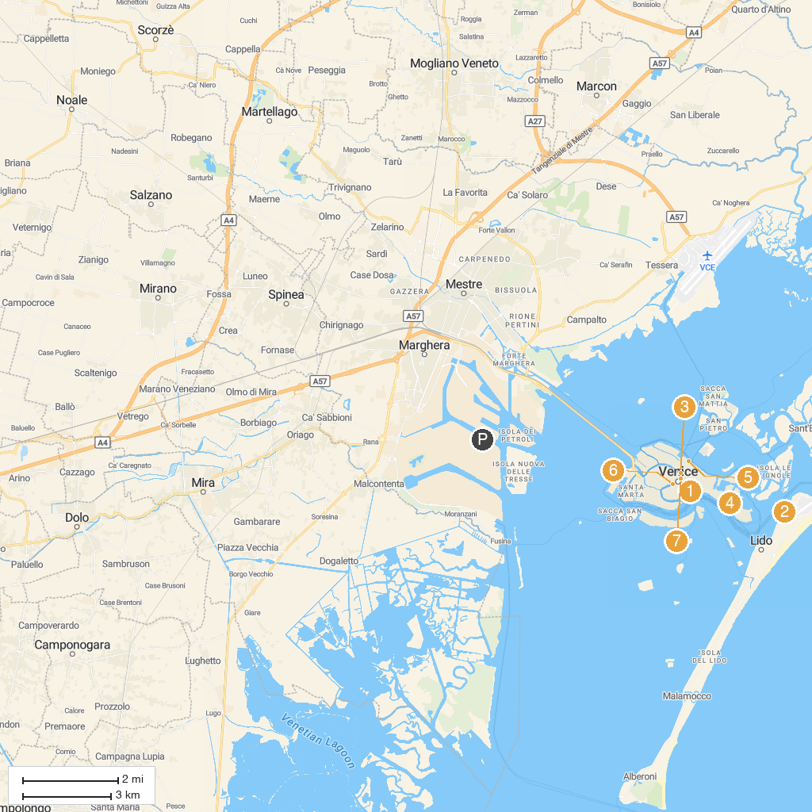
MAP KEY
1. Portrait of the Four Tetrarchs | 5. Church of Santa Maria Assunta ai Gesuiti
2. Parrocchia di San Nicolò di Lido | 6. Grand Canal
3. Ca' da Mosto | 7. Ponte di Rialto
4. Church of San Giuseppe di Castello
P. Cruise port / terminal
Map © MapTiler © OpenStreetMap contributors · cruiseports.org

