Vernon, Normandy, France
A picture-perfect Norman town on the Seine, Vernon is the doorstep to Giverny — where Monet painted his water lilies — and a gentle slice of authentic French life all its own.
⚓ River dock (no tender) · 🕒 Typical call: 7-9 hrs · 💶 Currency: Euro (€) · 🗣️ Language: French · 🌸 Seasonal: Giverny open Apr–Oct
✍️ MY DAY IN PORT (FILL IN)
Ship / Date
In port | arrive ______ · all aboard ______
Booked excursion
Notes / meeting point
GETTING ASHORE
- Docking: River berth alongside quay; ships dock in the town center
- Walk to center: 5 min stroll from dock to Vernon's historic core
- Best For: Monet's Giverny gardens, Impressionist art, Norman architecture
- Don't Miss: The Old Mill (Vieux-Moulin) straddling the medieval bridge on the Seine
GETTING AROUND
- 🚕 Taxi: ~€15–20 one-way to Giverny — Taxis are available in Vernon for on-demand trips to Giverny and beyond. Pre-booking is advisable during peak season (Ma
TOP THINGS TO DO
- Monet's House & Gardens, Giverny — Walk through the Clos Normand flower garden and the famous Japanese-bridge Water Garden that inspired Monet's Water Lilies series.
- Museum of Impressionism, Giverny — A world-class museum devoted to the Impressionist movement and the American artists who flocked to Giverny in Monet's wake.
- Château Gaillard & Les Andelys — Richard the Lionheart's dramatic clifftop castle towers above the Seine just 30 km upriver.
- Rouen — Gothic City on the Seine — Joan of Arc's city and home to one of France's finest Gothic cathedrals — the same façade Monet painted 30 times.
- Seine Valley Bike Ride — Rent a bicycle near Vernon station and pedal the flat greenway to Giverny along the Seine — a 5 km scenic ride through…
BEST WALKS
- Vernon Old Town & Seine Waterfront: 1.5 km · ~45 min · Easy — From the quay, walk along the riverfront to the iconic Vieux-Moulin (Old Mill) on the medieval…
- Bike or Walk to Giverny: 5 km one way · ~25 min by bike · Flat — A dedicated cycle/walking path traces the Seine valley from Vernon's train station area straight to…
WEATHER · DAYLIGHT · MONEY
Month | High °F | Low °F | Rainy days
May | 64 | 48 | 12
Jul | 76 | 59 | 8
Sep | 70 | 54 | 9
Daylight: May 6:11AM–9:30PM · Jul 6:06AM–9:53PM · Sep 7:30AM–8:06PM
cruiseports.org/vernon · Confirm terminal & all-aboard time with your ship

Vernon, Normandy, France — Port Map
Red = walkable sights · Amber = excursions farther out · P = cruise terminal
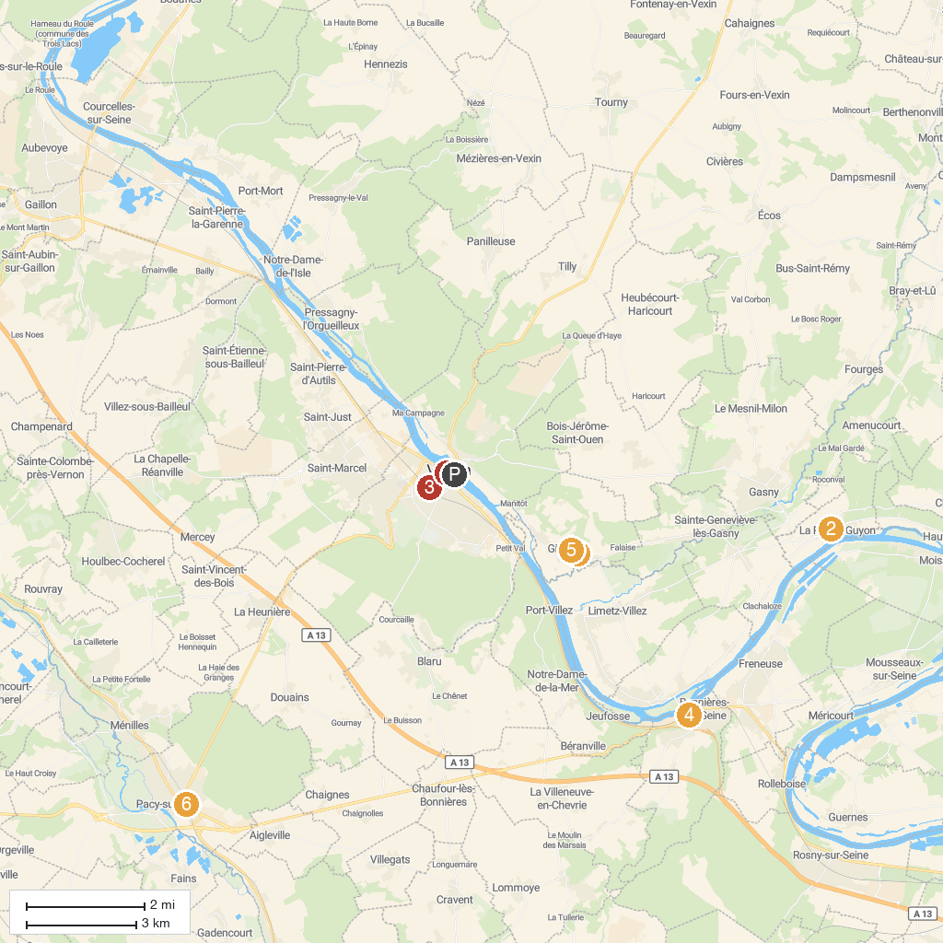
MAP KEY
1. Claude Monet's House and Gardens - Giverny | 5. Troglodyte church of the Annunciation
2. Castle of La Roche-Guyon | 6. Museum of Impressionism Giverny
3. Monet's Train - Givernon | 7. Chemin de Fer de la Vallée de l'Eure
4. House Agutte-Sembat VIVHAS | 8. Blanche Hoschedé-Monet Museum
P. Cruise port / terminal
Map © MapTiler © OpenStreetMap contributors · cruiseports.org

