Vibo Valentia, Calabria, Italy
A southern Italian gem on the Coast of the Gods — where a medieval hilltop castle overlooks turquoise waters and the road to Tropea begins at your gangway.
⚓ Pier (small ships dock; larger may tender) · 🕒 Typical call: 7-9 hrs · 💶 Currency: Euro (carry cash) · 🗣️ Language: Italian
✍️ MY DAY IN PORT (FILL IN)
Ship / Date
In port | arrive ______ · all aboard ______
Booked excursion
Notes / meeting point
GETTING ASHORE
- Docking: Pier at Vibo Marina; occasional tender for larger vessels
- Walk to center: 5 min to marina promenade; hilltop city 6 km — taxi or shuttle
- Best For: History, authentic Calabrian food, day trips to Tropea or Pizzo
- Don't Miss: Norman-Swabian Castle & the Golden Tablet of Orpheus museum
GETTING AROUND
- 🚕 Taxi: €40–€55 — Taxis wait at the pier and offer the fastest transfer to Tropea (~25 min) or up to Vibo Valentia city (~10 min, €10–€15)
- 📱 Rideshare: ✅ Uber
TOP THINGS TO DO
- Norman-Swabian Castle & Archaeological Museum — Frederick II's 13th-century hilltop fortress built on a Greek acropolis.
- Tropea — Cliffside Town & Beach — Calabria's most photogenic destination, 35 minutes south.
- Pizzo & Tartufo Tasting — The small cliff-top fishing town of Pizzo, 15 minutes north, is the birthplace of Tartufo di Pizzo — a globe of hazelnut and…
- Vibo Valentia Historic Center Walk — Wander the ancient lanes of the hilltop centro storico — cobblestone alleys flanked by yellow-stone palazzi, quiet piazzas, and…
- Beaches near Vibo Marina — The local Spiaggia di Vibo Marina is a 10-minute walk from the pier — sandy, clean, and used by locals.
BEST WALKS
- Marina Promenade Stroll: 0.5 km · 15 min · Flat · Easy — A leisurely flat walk along the seafront from the cruise pier to the local beach and back.
- Hilltop Historic Center: 1.5 km loop · 45-60 min · Moderate (after taxi up) — From the castle, wander the centro storico lanes to the Cathedral and then to the Belvedere Grande…
WEATHER · DAYLIGHT · MONEY
Month | High °F | Low °F | Rainy days
May | 73 | 58 | 10
Jul | 87 | 71 | 6
Sep | 81 | 67 | 12
Daylight: May 5:43AM–8:00PM · Jul 5:43AM–8:19PM · Sep 6:37AM–7:03PM
cruiseports.org/vibo-valentia · Confirm terminal & all-aboard time with your ship

Vibo Valentia, Calabria, Italy — Port Map
Red = walkable sights · Amber = excursions farther out · P = cruise terminal
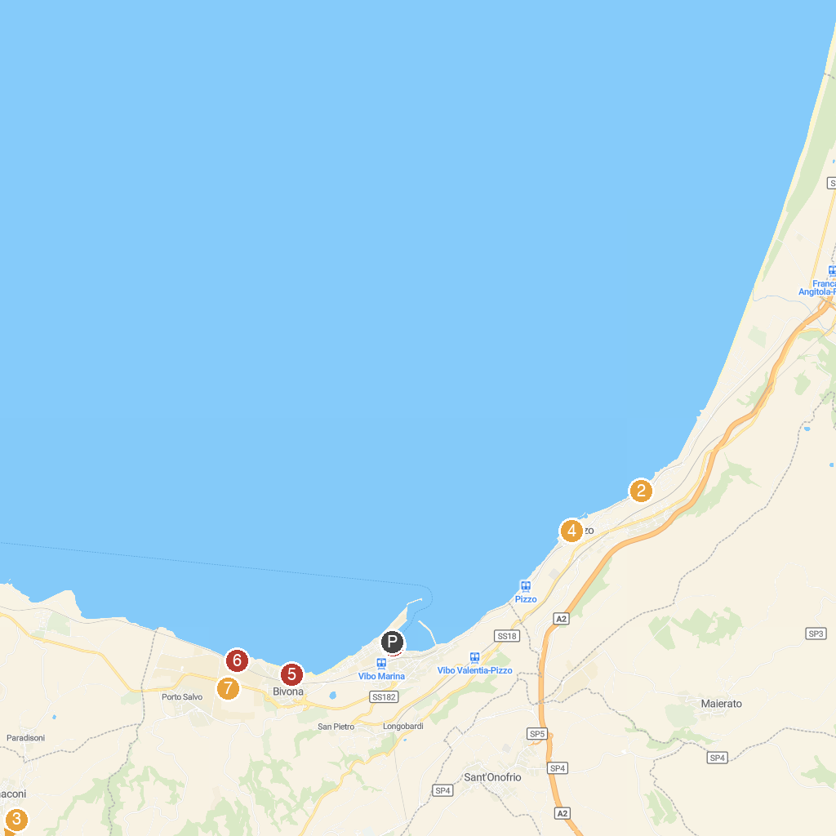
MAP KEY
1. Imbarco Escursioni da Vibo Marina Isole Eolie Savadori Navigazione | 5. Castello Murat
2. Church Piedigrotta | 6. Spiaggia di Bivona
3. Papaglionti Vecchia | 7. Bivona Paradise Beach
4. Rock Settlement and Museum of Rural Life of Zungri | 8. Bivona Castle (VV)
P. Cruise port / terminal
Map © MapTiler © OpenStreetMap contributors · cruiseports.org

