Vicksburg, Mississippi, USA
Perched on a high bluff above the Mississippi, Vicksburg rewrites American history at every turn — from a 47-day Civil War siege to the very room where Coca-Cola was first bottled.
⚓ Docked (river pier) · 🕒 Typical call: 7-9 hrs · 💵 US Dollar · 🗣️ English · 🏛️ Civil War history
✍️ MY DAY IN PORT (FILL IN)
Ship / Date
In port | arrive ______ · all aboard ______
Booked excursion
Notes / meeting point
GETTING ASHORE
- Docking: Tied up directly at Vicksburg Riverfront levee — no tender
- Walk to center: ~0.2 mi but a steep bluff climb; cruise lines provide shuttles
- Best For: Civil War buffs, history lovers, Southern food fans
- Don't Miss: USS Cairo at Vicksburg National Military Park
GETTING AROUND
- 🚕 Taxi: $5–10/person — Local taxis serve the port area; short trips to downtown run roughly $5–10 per person. Daniels Taxi & Shuttle is one loc
- 📱 Rideshare: ✅ Uber
TOP THINGS TO DO
- Vicksburg National Military Park — The 47-day 1863 siege that split the Confederacy in two is preserved across 1,800 acres of earthworks, monuments, and cannon…
- Biedenharn Coca-Cola Museum — In 1894 Joseph Biedenharn bottled Coca-Cola for the first time ever in this very building.
- Old Court House Museum — Built by enslaved craftsmen in 1858 and perched at the highest point downtown, this Greek Revival courthouse survived the siege…
- Vicksburg Riverfront Murals — Thirty-two massive photorealistic murals painted on the floodwall right at the dock depict the city's history — the Civil War…
- McRaven Tour Home — Three architectural eras (1797 to 1849) collide in Mississippi's most-haunted house, used as a Confederate field hospital during…
BEST WALKS
- Floodwall Murals to Downtown: 0.5 mi · Moderate (steep hill) · 20-30 min — Start at the ship, walk the levee to take in the 32 giant floodwall murals, then climb Clay Street…
- Downtown History Loop: 1 mi · Moderate · 45-60 min — From Washington Street, walk south to the Old Court House Museum at the crest of the hill, then…
WEATHER · DAYLIGHT · MONEY
Month | High °F | Low °F | Rainy days
May | 82 | 65 | 11
Jul | 91 | 75 | 12
Sep | 88 | 71 | 8
Daylight: May 6:05AM–7:54PM · Jul 6:07AM–8:11PM · Sep 6:47AM–7:08PM
cruiseports.org/vicksburg-ms · Confirm terminal & all-aboard time with your ship

Vicksburg, Mississippi, USA — Port Map
Red = walkable sights · Amber = excursions farther out · P = cruise terminal
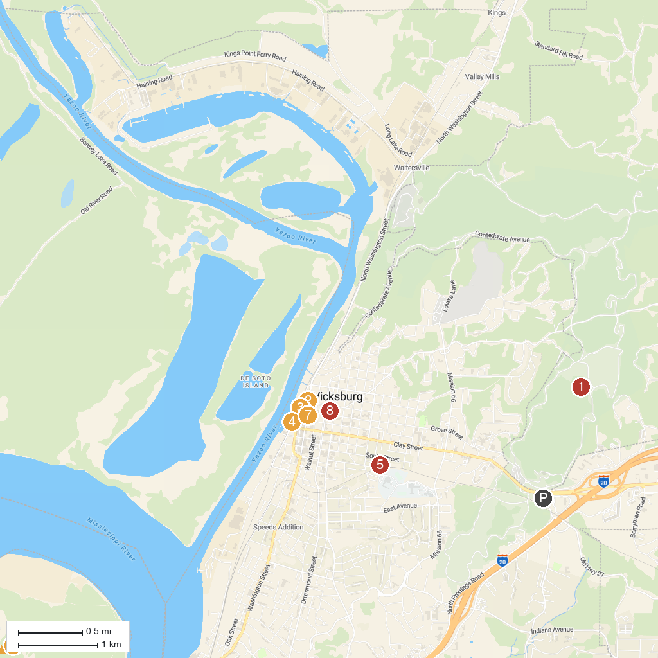
MAP KEY
1. Vicksburg National Military Park | 5. McRaven Tour Home
2. Lower Mississippi River Museum | 6. Grant's Canal
3. The Old Depot Museum | 7. Biedenharn Coca-Cola Museum
4. Vicksburg Riverfront Murals | 8. Old Court House Museum
P. Cruise port / terminal
Map © MapTiler © OpenStreetMap contributors · cruiseports.org

