Vigo, Galicia, Spain
Atlantic Spain at its most authentic — Celtic roots, granite lanes, fresh oysters on the quay, and a national park beach once voted the world's best. All of it within easy reach of your ship.
⚓ Docked (Muelle de Transatlanticos) · 🕒 Typical call: 8-10 hrs · 💶 Currency: Euro (€) · 🗣️ Spanish & Galician
✍️ MY DAY IN PORT (FILL IN)
Ship / Date
In port | arrive ______ · all aboard ______
Booked excursion
Notes / meeting point
GETTING ASHORE
- Docking: Pier — Muelle de Transatlanticos, city center waterfront
- Walk to center: 3-5 min to Old Town (Casco Vello); 15 min to main shopping street
- Best For: Seafood lovers, history walkers, beach day-trippers (Cíes Islands)
- Don't Miss: Oysters on Rúa da Pescadería, Castro Castle views, Vigo Vertical escalators
GETTING AROUND
- 🚕 Taxi: ~€5 — Taxis queue at the port exit. A short ride to the old town runs about €5 using the meter (day rate: €4.10 base + €1.10/k
- 📱 Rideshare: ✅ Uber
- 🚌 Hop-on hop-off: ✅
TOP THINGS TO DO
- Cíes Islands National Park — Ferry to the Atlantic Islands National Park — white-sand Rodas Beach, turquoise water, and wild dunes in a protected reserve.
- Castillo del Castro & Old Town Walk — Climb (or escalate) to Vigo's 17th-century hilltop fortress for sweeping views of the ría, then wind through the granite lanes of…
- Galician Seafood & Oyster Street — Rúa da Pescadería in the Old Town is lined with stalls where vendors shuck fresh local oysters right in front of you.
- Samil Beach — Vigo's main city beach — a wide arc of fine white sand with a long promenade, cafés, and sports facilities.
- Pazo de Castrelos & Gardens — A 17th-century manor house turned municipal museum, surrounded by formal English and French gardens.
BEST WALKS
- Old Town & Castro Castle Loop: 3-4 km · 2-2.5 hrs · Moderate (uphill sections) — From the cruise terminal, cross into the Casco Vello, browse Rúa da Pescadería (oyster street)…
- Harbor Promenade & Jules Verne Statue: 1.5 km · 30-45 min · Easy (flat) — A simple waterfront stroll south from the cruise terminal along the Paseo de Alfonso XII to the…
WEATHER · DAYLIGHT · MONEY
Month | High °F | Low °F | Rainy days
May | 68 | 53 | 11
Jul | 77 | 61 | 5
Sep | 74 | 59 | 8
Daylight: May 7:13AM–9:49PM · Jul 7:12AM–10:09PM · Sep 8:15AM–8:44PM
cruiseports.org/vigo · Confirm terminal & all-aboard time with your ship

Vigo, Galicia, Spain — Port Map
Red = walkable sights · Amber = excursions farther out · P = cruise terminal
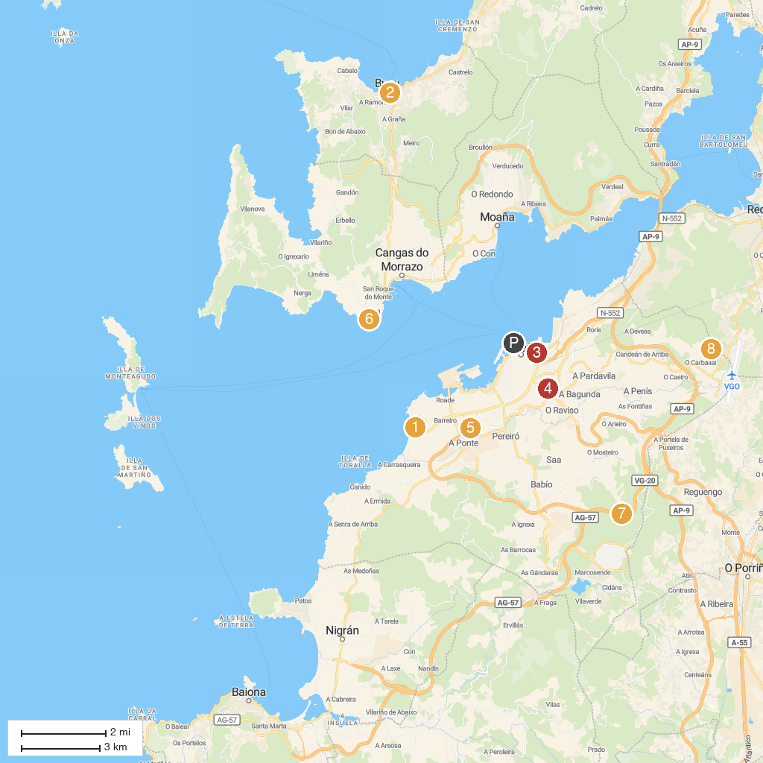
MAP KEY
1. Museo Verbum - Casa das Palabras | 5. Parque da Bouza
2. Museo Massó | 6. Praia de Areamilla
3. Salinae - Centro Arqueolóxico do Areal | 7. Parque Botanico Arco Da Vella Capilla San Cibran
4. Pazo de San Roque | 8. Parque forestal Bandeira - Cabral
P. Cruise port / terminal
Map © MapTiler © OpenStreetMap contributors · cruiseports.org

