Vilagarcía de Arousa, Galicia, Spain
Gateway to the Camino, home of Albariño wine, and epicentre of Galicia's extraordinary seafood culture — Vilagarcía packs serious reward into a compact shore day.
⚓ Pier (docked) · 🕒 Typical call: 8-10 hrs · 💶 Currency: Euro · 🗣️ Language: Spanish / Galician
✍️ MY DAY IN PORT (FILL IN)
Ship / Date
In port | arrive ______ · all aboard ______
Booked excursion
Notes / meeting point
GETTING ASHORE
- Docking: Pier — O Ramal or Comercial docks; no tender
- Walk to centre: 10–15 min on flat promenade (~800 m)
- Best For: Santiago day trip, Albariño wine, fresh shellfish
- Don't Miss: Carril clams, Pazo de Rubiáns gardens, train to Santiago
GETTING AROUND
- 🚕 Taxi: €5–€12 — Local taxis are available at the port. The short hop to the city center costs only a few euros; fares to nearby towns li
- 📱 Rideshare: ❌ not available
- 🚌 Hop-on hop-off: ✅ Tin Ti Lan
TOP THINGS TO DO
- Santiago de Compostela Day Trip — The top reason ships call here.
- Albariño Wine & Pazo de Rubiáns — A 10-minute taxi ride brings you to this magnificent 18th-century manor house set among Albariño vineyards, crowned with an…
- Pontevedra Medieval City Walk — Galicia's most beautifully preserved medieval city is just 15–20 minutes by train.
- Ría de Arousa & Mussel Platforms — The estuary is home to thousands of wooden bateas — floating platforms producing roughly 15% of the world's mussels.
- Carril Clam Village & Seafood Lunch — Stroll the seafront promenade 2 km to the traditional fishing village of Carril — capital of the famous almejas de Carril (clams).
BEST WALKS
- Pier to Town Centre & Convento Vista Alegre: 1.5 km · 20 min · flat — Leave the pier, follow the waterfront promenade to Plaza de Galicia, then continue to the…
- Promenade Walk to Carril: 2 km · 25 min · flat — Follow the Paseo Marítimo northeast along the estuary shore past Praia de Compostela (beach) to the…
WEATHER · DAYLIGHT · MONEY
Month | High °F | Low °F | Rainy days
May | 68 | 53 | 10
Jul | 78 | 61 | 5
Sep | 74 | 59 | 9
Daylight: May 7:13AM–9:50PM · Jul 7:11AM–10:10PM · Sep 8:15AM–8:44PM
cruiseports.org/vilagarcia-de-arousa · Confirm terminal & all-aboard time with your ship

Vilagarcía de Arousa, Galicia, Spain — Port Map
Red = walkable sights · Amber = excursions farther out · P = cruise terminal
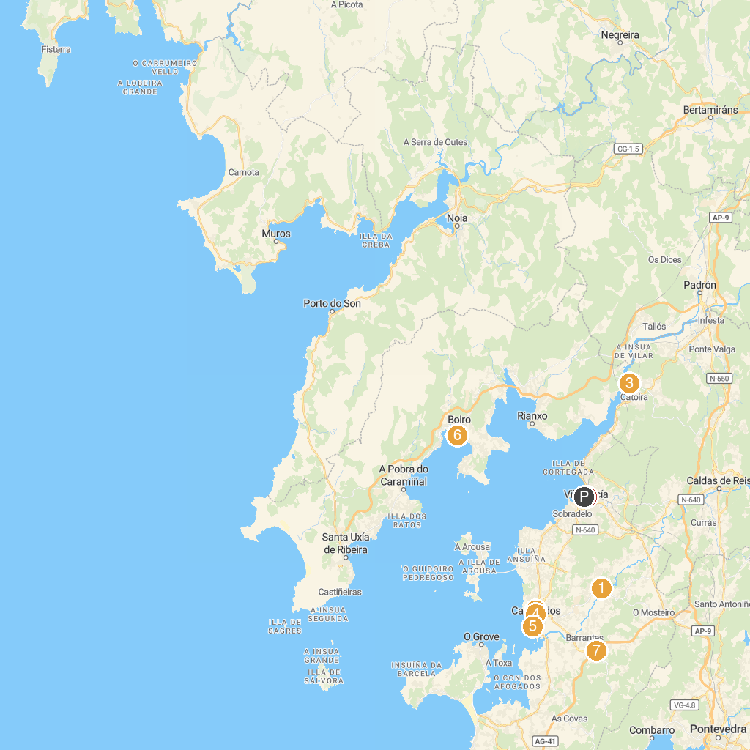
MAP KEY
1. Puente de los Padrinos limitado 7t toneladas | 5. Pazo de Montesacro
2. Casa Histórica de Cambados | 6. Paseo marítimo de Barraña
3. Torres do Oeste | 7. Ruta da Pedra e da Auga
4. Pazo Torrado | 8. Parque Miguel Hernández
P. Cruise port / terminal
Map © MapTiler © OpenStreetMap contributors · cruiseports.org

