Villefranche-sur-Mer, Côte d'Azur, France
Ships anchor in one of the Mediterranean's deepest natural bays, framed by pastel-washed fishing houses and the hills of the French Riviera. Nice is about 10 minutes by train; Monaco about 15.
⚓ Tender port · 🕒 Typical call: 7-10 hrs · 💶 Currency: Euro · 🗣️ Language: French
✍️ MY DAY IN PORT (FILL IN)
Ship / Date
In port | arrive ______ · all aboard ______
Booked excursion
Notes / meeting point
GETTING ASHORE
- Docking: Tender only — ships anchor in the bay; tenders drop at Quai Courbet
- Walk to center: 1 min from tender dock to the old town and beach
- Best For: Day trips to Nice, Monaco & Eze; beachside lunch; Cocteau chapel
- Don't Miss: Chapelle Saint-Pierre (Cocteau frescoes) & Rue Obscure
GETTING AROUND
- 🚕 Taxi: €30–45 to Nice — Taxis wait near the tender dock. Expect €30–45 to Nice city centre and €35–50 to Monaco; agree on price before departing
- 📱 Rideshare: ✅ Uber
- 🚌 Hop-on hop-off: ✅ Nice Le Grand Tour
TOP THINGS TO DO
- Nice City Day — The Cours Saleya flower market, Promenade des Anglais, and the colorful Old Town (Vieux-Nice) are easily done independently by…
- Monaco & Monte Carlo — Hop the train to Monaco for the Prince's Palace, the Casino de Monte-Carlo, and a stroll through the Condamine market.
- Eze Village & Perfumeries — The medieval perched village of Eze sits roughly 430 m above the sea with panoramic Riviera views.
- Chapelle Saint-Pierre & Old Villefranche — Jean Cocteau decorated this tiny 14th-century fishermen's chapel with vivid frescoes in 1957.
- Villefranche Beach — The sandy beach directly below the old town is one of the nicest in the area — calmer than Nice's stone beach.
BEST WALKS
- Old Villefranche Loop: 1.5 km · 45–60 min · Easy · Start: Quai Courbet — From the tender dock, walk along the quay to Chapelle Saint-Pierre, duck into Rue Obscure (the…
- Cap Ferrat Coastal Path: 8 km round-trip · 2.5–3 hrs · Moderate · Start: Villefranche port — A well-signed coastal path circles the Cap Ferrat peninsula with excellent sea views, passing…
WEATHER · DAYLIGHT · MONEY
Month | High °F | Low °F | Rainy days
May | 70 | 56 | 10
Jul | 84 | 70 | 5
Sep | 77 | 64 | 8
Daylight: May 6:05AM–8:49PM · Jul 6:03AM–9:09PM · Sep 7:10AM–7:40PM
cruiseports.org/villefranche-sur-mer · Confirm terminal & all-aboard time with your ship

Villefranche-sur-Mer, Côte d'Azur, France — Port Map
Red = walkable sights · Amber = excursions farther out · P = cruise terminal
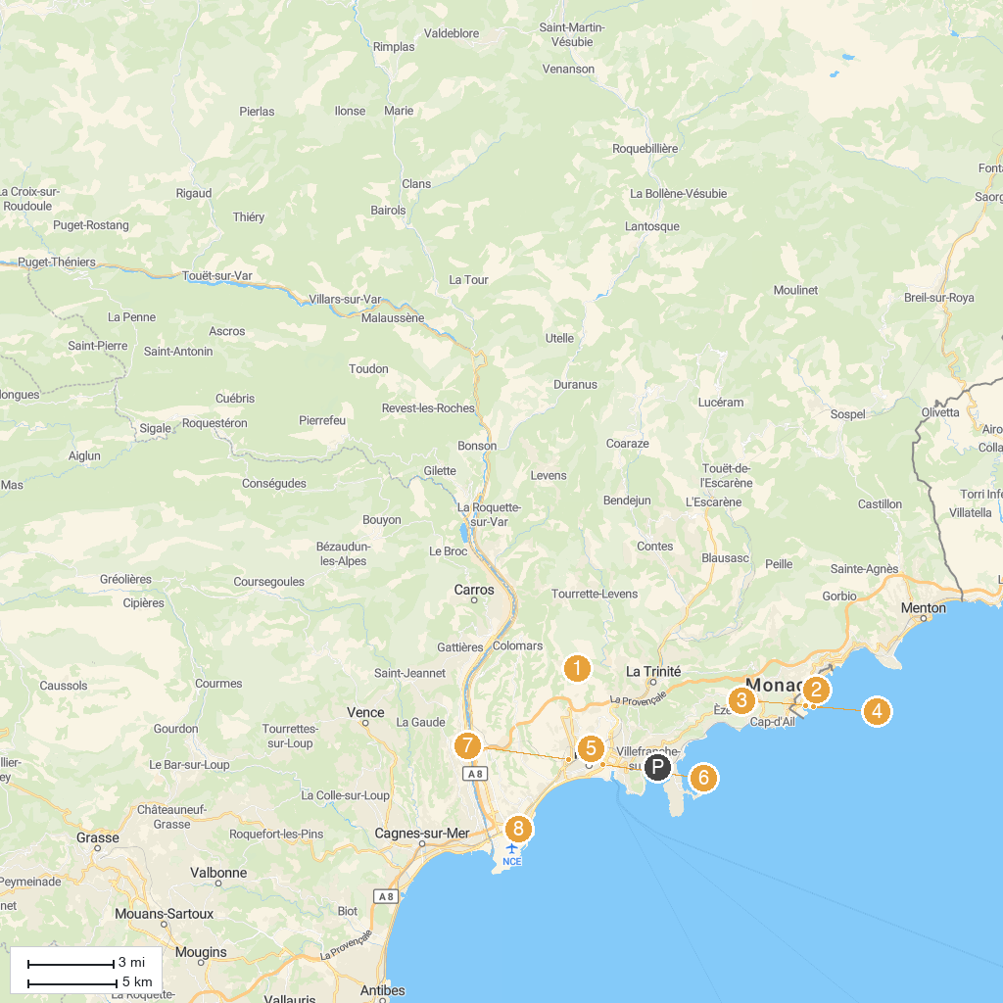
MAP KEY
1. Pyramid of Falicon | 5. Marc Chagall National Museum
2. Casino de Monte-Carlo | 6. Modern and Contemporary Art Museum (MAMAC)
3. Prince's Palace of Monaco | 7. Cathédrale Saint-Nicolas de Nice
4. Musée océanographique de Monaco | 8. Parc Phœnix
P. Cruise port / terminal
Map © MapTiler © OpenStreetMap contributors · cruiseports.org

