Viviers-sur-Rhône, Ardèche, France
The smallest active cathedral city in France feels frozen in the Middle Ages — pale limestone laneways, a soaring hilltop cathedral, and sweeping views over the Rhône River await just minutes from your ship.
⚓ Docked (river quay) · 🕒 Typical call: 5–8 hrs · 💶 Currency: Euro · 🗣️ Language: French · 🥾 Hilly Upper Town — sturdy shoes essential
✍️ MY DAY IN PORT (FILL IN)
Ship / Date
In port | arrive ______ · all aboard ______
Booked excursion
Notes / meeting point
GETTING ASHORE
- Docking: Docked alongside river quay (Port de Viviers) — no tender
- Walk to Center: ~10–15 min flat walk (800 m) to old town gate; Upper Town is steep
- Best For: Medieval history, cathedral architecture, panoramic Rhône views, Ardèche wine
- Don't Miss: Cathédrale Saint-Vincent and the belvedere terrace overlooking the river
GETTING AROUND
- 🚕 Taxi: €10–€20 (local trips) — Local taxis are available for short trips around town or transfers to nearby villages. Fares are metered; inter-town rid
- 📱 Rideshare: ✅ Uber
TOP THINGS TO DO
- Old Town & Cathedral Walking Tour — A guided loop through the Lower and Upper Towns takes in the Maison des Chevaliers' Renaissance facade, the 11th–18th-century…
- ViaRhôna Cycling Along the Rhône — Viviers sits on the ViaRhôna, an 815 km dedicated cycle route.
- Ardèche Gorges Excursion — Venture inland to the spectacular Ardèche Gorges — dramatic limestone canyon country with kayaking, hiking, and the Pont d'Arc…
- Montélimar Nougat & Côtes du Rhône Wine — Montélimar, the nougat capital of France, is just 15 km south — a classic port excursion combines a nougat factory tour with…
- Rochemaure Medieval Village — A short drive south along the ViaRhôna, Rochemaure perches above the Rhône with a 12th-century volcanic-rock castle, a suspension…
BEST WALKS
- Quay to Cathedral Belvedere: 2.5 km round-trip | ~45–60 min | Moderate (steep climb) — From the riverside quay, follow the promenade to Porte de la Gâche, then climb through the Lower…
- Promenade & Place de la République: 1 km loop | ~20 min | Easy (flat) — A gentle stroll along the plane-tree-lined promenade to the main square, where café terraces, a…
WEATHER · DAYLIGHT · MONEY
Month | High °F | Low °F | Rainy days
May | 71 | 54 | 9
Jul | 86 | 67 | 5
Sep | 77 | 60 | 7
Daylight: May 6:13AM–9:01PM · Jul 6:11AM–9:22PM · Sep 7:20AM–7:51PM
cruiseports.org/viviers-sur-rhone · Confirm terminal & all-aboard time with your ship

Viviers-sur-Rhône, Ardèche, France — Port Map
Red = walkable sights · Amber = excursions farther out · P = cruise terminal
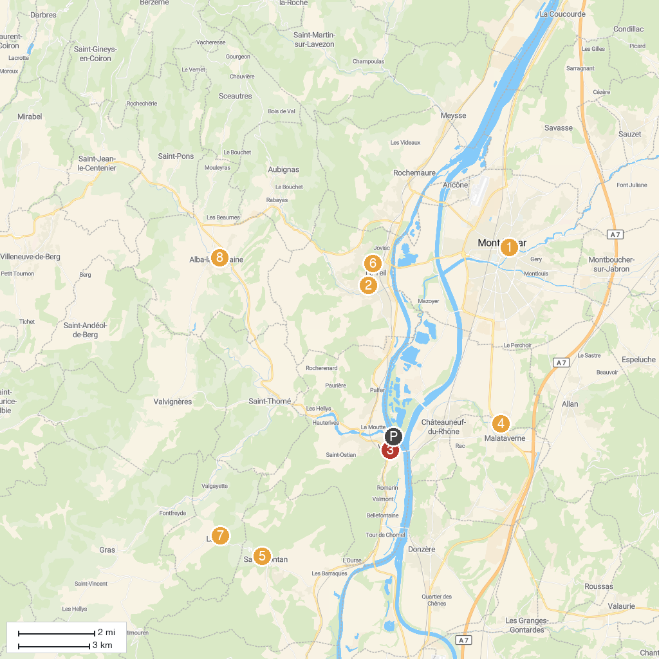
MAP KEY
1. Montelimar Castle | 5. Medieval Castle of Saint Montan
2. Musée de la Résistance et de la Déportation en Ardèche | 6. Joncas Aventure
3. Viviers Cathedral | 7. Église Saint-Pierre de Larnas
4. Recrea 9 Aire de jeux | 8. Château d'Alba
P. Cruise port / terminal
Map © MapTiler © OpenStreetMap contributors · cruiseports.org

