Washington, DC, USA
The only cruise port that puts you steps from the most powerful address on earth. Small ships dock right at The Wharf — monuments, museums, and history await, most of it completely free.
⚓ Pier — The Wharf (small ships only) · 🕒 Typical call: full day · 💵 USD · 🗣️ English · 🏛️ World-class free museums
✍️ MY DAY IN PORT (FILL IN)
Ship / Date
In port | arrive ______ · all aboard ______
Booked excursion
Notes / meeting point
GETTING ASHORE
- Docking: Pier at The Wharf, SW Waterfront
- Walk to Mall: ~15 min (0.8 mi) to Smithsonian Castle
- Best For: History, monuments, world-class free museums
- Don't Miss: The National Mall — Lincoln Memorial to the Capitol
GETTING AROUND
- 🚕 Taxi: $5–$15 — Metered taxis are plentiful; the National Mall is roughly $5–7 away. Fare starts at $4 for the first 1/8 mile, then $2.5
- 📱 Rideshare: ✅ Uber, Lyft
- 🚌 Hop-on hop-off: ✅
TOP THINGS TO DO
- National Mall Monument Walk — A 2-mile stretch from the Lincoln Memorial past the WWII and Vietnam memorials to the Washington Monument and Capitol.
- Smithsonian Museum Immersion — The world's largest museum complex — Air & Space, Natural History (Hope Diamond), American History (Star-Spangled Banner) — all…
- U.S. Capitol & Library of Congress — Tour the Capitol's Visitor Center for free — advance reservations recommended.
- International Spy Museum — Hands-on espionage museum where you take on a cover identity and work through interactive missions.
- Arlington National Cemetery — Cross the Potomac into Virginia to witness the solemn Changing of the Guard at the Tomb of the Unknown Soldier and pay respects…
BEST WALKS
- The Wharf to Lincoln Memorial: 1.5 miles · ~30 min one-way · Flat — Walk north along the waterfront, then turn up 15th St SW past the new development to the Tidal…
- Mall East: Smithsonians to the Capitol: 1.2 miles · ~25 min one-way · Flat — Walk the east half of the Mall from the Washington Monument past the Smithsonian Castle, Natural…
WEATHER · DAYLIGHT · MONEY
Month | High °F | Low °F | Rainy days
May | 75 | 56 | 12
Jul | 88 | 70 | 14
Sep | 80 | 63 | 10
Daylight: May 5:55AM–8:13PM · Jul 5:55AM–8:32PM · Sep 6:50AM–7:15PM
cruiseports.org/washington-dc · Confirm terminal & all-aboard time with your ship

Washington, DC, USA — Port Map
Red = walkable sights · Amber = excursions farther out · P = cruise terminal
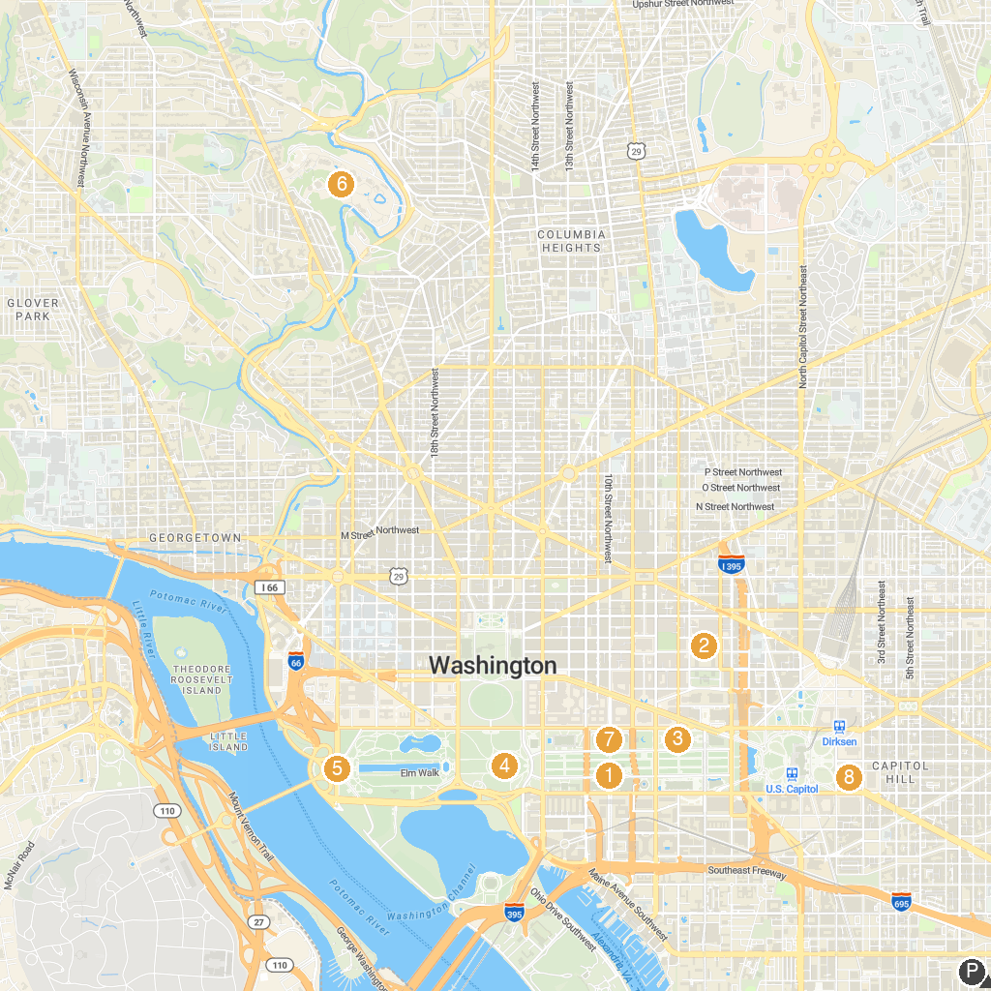
MAP KEY
1. Smithsonian Castle | 5. Lincoln Memorial
2. National Building Museum | 6. Smithsonian National Zoological Park
3. National Gallery of Art | 7. Smithsonian National Museum of Natural History
4. Washington Monument | 8. Library of Congress
P. Cruise port / terminal
Map © MapTiler © OpenStreetMap contributors · cruiseports.org

