Wellington, North Island, New Zealand
New Zealand's wind-swept capital punches well above its size — a harbour city of world-class museums, quirky neighbourhoods, and stunning hilltop lookouts, all within reach of a cruise day ashore.
⚓ Docked (Aotea Quay or Queens Wharf) · 🕒 Typical call: 8-10 hrs · 💵 NZD (NZ Dollar) · 🗣️ English & Māori
✍️ MY DAY IN PORT (FILL IN)
Ship / Date
In port | arrive ______ · all aboard ______
Booked excursion
Notes / meeting point
GETTING ASHORE
- Docking: CentrePort Aotea Quay (larger ships) or Queens Wharf (smaller ships); shuttle to city centre
- Walk to Centre: ~10 min shuttle or 20 min walk from Queens Wharf; walking from Aotea Quay not permitted
- Best For: Museums, culture, wildlife, café-hopping, Lord of the Rings fans
- Don't Miss: Te Papa Tongarewa, Wellington Cable Car & Botanic Garden
GETTING AROUND
- 🚕 Taxi: NZ$15–25 — Taxis available at the terminal; approx 2–3 km to city center. Base fare NZ$3.98 plus NZ$3.25/km (2024 tariff).
- 📱 Rideshare: ✅ Uber
- 🚌 Hop-on hop-off: ✅ Tranzit Coachlines
TOP THINGS TO DO
- Te Papa Tongarewa National Museum — New Zealand's flagship national museum is a short shuttle ride from the port and free to enter.
- Wellington Cable Car & Botanic Garden — Ride the historic red cable car from Lambton Quay up to Kelburn for panoramic harbour views, then stroll downhill through the…
- Zealandia Ecosanctuary — A predator-fenced urban wildlife sanctuary just 2 km from the city centre, home to kiwi, tuatara, kākā parrots, and rare wētā.
- Weta Workshop Unleashed — Go behind the scenes at the world-famous special-effects studio responsible for Lord of the Rings, Avatar, and more.
- Seal Coast Safari — A 4WD safari along Wellington's rugged south coast to see New Zealand fur seals on the rocks at Red Rocks Reserve.
BEST WALKS
- Waterfront to Cuba Street: 2-3 km · 45-60 min · Flat · Easy — Start at the Te Papa waterfront, stroll north past Frank Kitts Park and Civic Square, then cut west…
- Mount Victoria Lookout: 3 km loop · 60-90 min · Moderate hills · Great views — From the city centre, follow the signs up to the summit of Mount Victoria (196 m) for 360° views of…
- Heritage Cable Car Walk: 3 km one-way · 90 min · Downhill · Easy — Take the cable car from Lambton Quay to Kelburn, explore the Botanic Garden, then walk downhill…
WEATHER · DAYLIGHT · MONEY
Month | High °F | Low °F | Rainy days
May | 59 | 53 | 12
Jul | 54 | 47 | 13
Sep | 55 | 49 | 12
Daylight: May 7:22AM–5:11PM · Jul 7:43AM–5:10PM · Sep 6:22AM–6:10PM
cruiseports.org/wellington · Confirm terminal & all-aboard time with your ship

Wellington, North Island, New Zealand — Port Map
Red = walkable sights · Amber = excursions farther out · P = cruise terminal
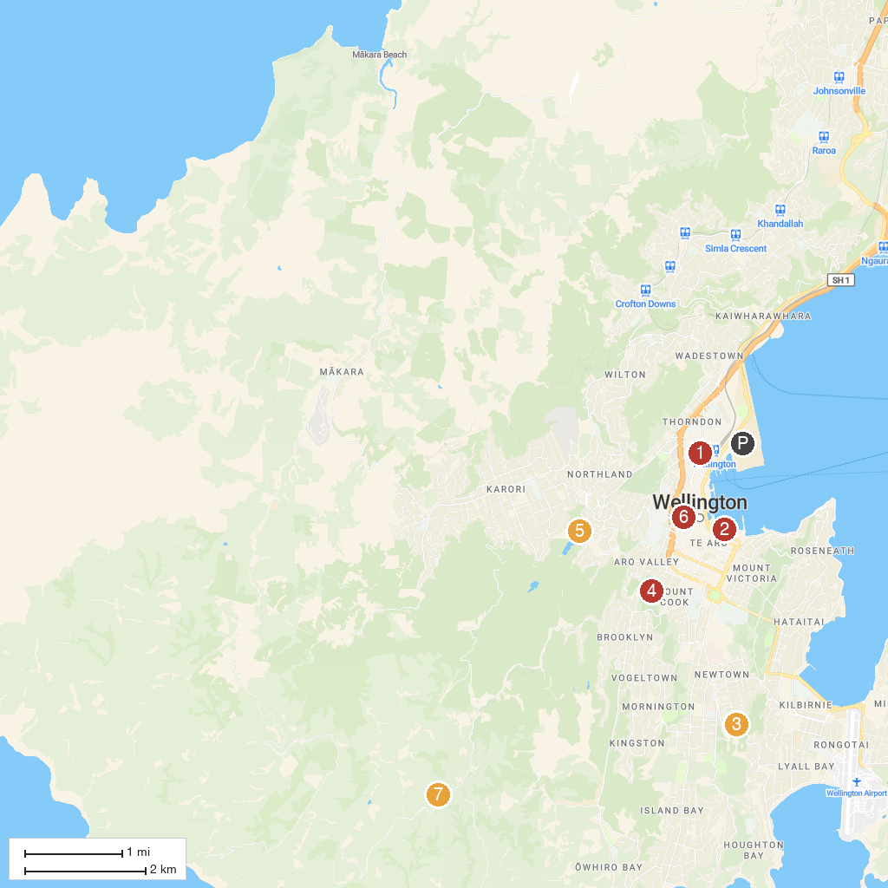
MAP KEY
1. Wellington Cenotaph | 5. Zealandia Te Māra a Tāne
2. Museum of New Zealand Te Papa Tongarewa | 6. National Shrine of St Mary of the Angels
3. Wellington Zoo | 7. Hawkins Hill Radar Dome
4. Central Park
P. Cruise port / terminal
Map © MapTiler © OpenStreetMap contributors · cruiseports.org

