Wertheim am Main, Baden-Württemberg, Germany
One of the Main River's most photogenic stops, Wertheim am Main has been spared by centuries of conflict — its 16th-century market square, leaning half-timbered houses, and hilltop castle ruins look much as they did 500 years ago.
⚓ Docked (river pontoon pier) · 🕒 Typical call: 6–8 hrs · 💶 Currency: Euro (€) · 🗣️ Language: German · 🍷 Franconian wine country
✍️ MY DAY IN PORT (FILL IN)
Ship / Date
In port | arrive ______ · all aboard ______
Booked excursion
Notes / meeting point
GETTING ASHORE
- Docking: River pontoon along Mainvorland promenade — no tender
- Walk to center: 2–5 min to Maintor gate; 5–7 min to Marktplatz
- Best For: Medieval architecture, castle views, wine tasting
- Don't Miss: Burg Wertheim ruins and the Tauber–Main confluence
GETTING AROUND
- 🚕 Taxi: €4.50–€8 (short hops) — Local taxis follow the Main-Tauber district tariff (base €4.50 day / €5.50 night, then ~€2.60–2.80/km). Given the compac
TOP THINGS TO DO
- Burg Wertheim Castle Ruins — One of southern Germany's largest stone castle ruins, dating to the 12th century.
- Glasmuseum Wertheim — Three thousand years of glassmaking history, from Roman vessels to precision laboratory glass, with live glassblowing…
- Franconian Wine Tasting — This is the northern edge of Franconia's wine region.
- Marktplatz & Old Town Walk — Stroll the 16th-century market square anchored by the red-sandstone Engelsbrunnen (1574), admire the Zobel'sche Haus (1520) — one…
- Tauber–Main Confluence (Spitze) — A short flat walk to the peninsula tip where the muddy Tauber flows visibly into the green Main.
BEST WALKS
- Old Town & Castle Loop: 2–3 hrs · Moderate (steep castle climb) — From the pier, enter through the Maintor gate, cross the Marktplatz, visit the Stiftskirche and…
- Confluence Promenade: 45 min · Easy, flat — Head downriver along the promenade to the Spitze peninsula where the Tauber meets the Main.
WEATHER · DAYLIGHT · MONEY
Month | High °F | Low °F | Rainy days
May | 66 | 48 | 11
Jul | 78 | 60 | 11
Sep | 69 | 53 | 8
Daylight: May 5:37AM–9:00PM · Jul 5:31AM–9:24PM · Sep 6:58AM–7:34PM
cruiseports.org/wertheim-am-main · Confirm terminal & all-aboard time with your ship

Wertheim am Main, Baden-Württemberg, Germany — Port Map
Red = walkable sights · Amber = excursions farther out · P = cruise terminal
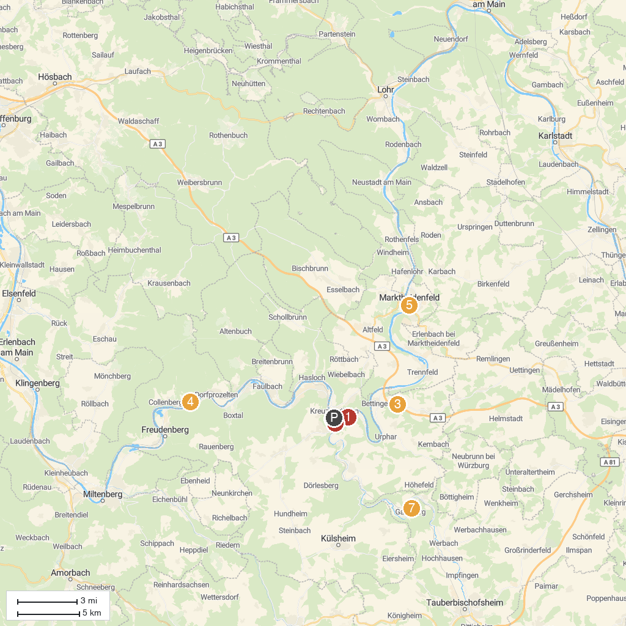
MAP KEY
1. Castle in the courtyard garden | 5. Franck-Haus
2. Spitzer Turm | 6. Burg Freudenburg
3. TOPPELS - Verdrehte Welt | 7. Glasmuseum Wertheim
4. Kollenburg | 8. Castle and Castle Park Gamburg
P. Cruise port / terminal
Map © MapTiler © OpenStreetMap contributors · cruiseports.org

