West Palm Beach, Florida, USA
Florida's Palm Beaches offer a gilded mix of Flagler-era mansions, clear Atlantic waters, and a JFK-era Cold War secret right in the harbor. West Palm Beach punches well above its modest cruise-port profile.
⚓ Pier (docked) · 🕒 Typical call: 6-8 hrs · 💵 USD · 🗣️ English · 🌴 Homeport for Margaritaville at Sea
✍️ MY DAY IN PORT (FILL IN)
Ship / Date
In port | arrive ______ · all aboard ______
Booked excursion
Notes / meeting point
GETTING ASHORE
- Docking: Pier — ships dock directly at the Port of Palm Beach cruise terminal (Riviera Beach)
- Walk to center: Not walkable — port is in an industrial zone; 15-min rideshare to downtown WPB or Palm Beach
- Best For: Gilded Age history, snorkeling on Peanut Island, upscale shopping on Worth Avenue
- Don't Miss: Flagler Museum (Whitehall) and the JFK nuclear bunker site on Peanut Island
GETTING AROUND
- 🚕 Taxi: $12–$20 — Metered taxis are available at the Cruise Port of Palm Beach. The ride to downtown West Palm Beach takes about 10–15 min
- 📱 Rideshare: ✅ Uber, Lyft
TOP THINGS TO DO
- Flagler Museum (Whitehall) — Henry Flagler's 75-room Gilded Age mansion on Palm Beach Island was built as a wedding present in 1902.
- Peanut Island & JFK Bunker — An ~80-acre county park in Lake Worth Inlet with crystal-clear water and a Cold War secret: a fallout shelter ("Detachment…
- Singer Island / Ocean Reef Park — A wide, uncrowded Atlantic beach with lifeguards, a boardwalk, showers, and picnic areas — far quieter than Miami or Fort…
- Clematis Street & Downtown WPB — The walkable historic core of West Palm Beach, lined with boutiques, colorful murals, and outdoor cafés.
- Manatee Lagoon (FPL Eco-Discovery Center) — A free eco-discovery center just north of the port where wild Florida manatees gather in the warm-water outflows of the FPL power…
BEST WALKS
- Clematis Street to The Square: 1 mile · Flat · 20-30 min — Stroll from the Clematis Street waterfront through the historic downtown core to The Square's…
- Worth Avenue Stroll, Palm Beach: 0.5 mile · Flat · 30-45 min — Walk Worth Avenue end to end, ducking into the hidden cobblestone Vias for art galleries and cafés.
WEATHER · DAYLIGHT · MONEY
Month | High °F | Low °F | Rainy days
May | 82 | 73 | 16
Jul | 87 | 77 | 25
Sep | 85 | 77 | 24
Daylight: May 6:32AM–8:00PM · Jul 6:36AM–8:15PM · Sep 7:06AM–7:24PM
cruiseports.org/west-palm-beach · Confirm terminal & all-aboard time with your ship

West Palm Beach, Florida, USA — Port Map
Red = walkable sights · Amber = excursions farther out · P = cruise terminal
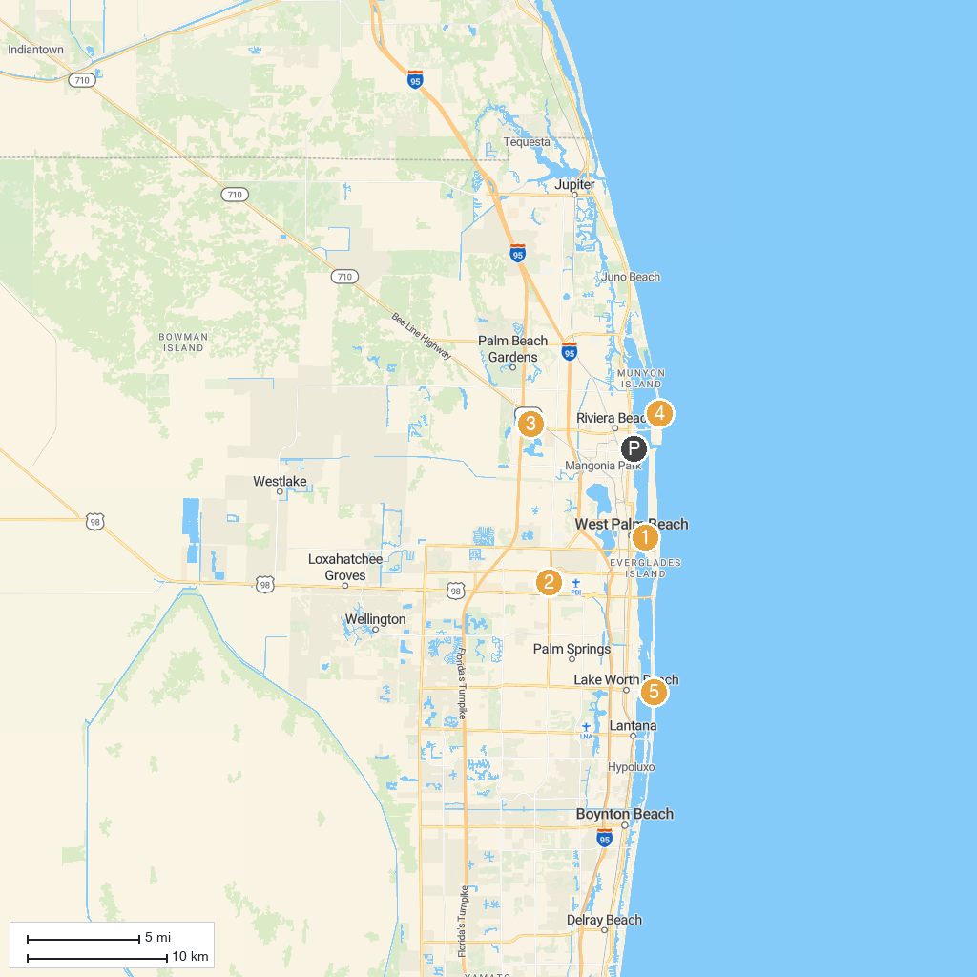
MAP KEY
1. Henry Morrison Flagler Museum | 5. Dyer Park
2. John Prince Park | 6. Ocean Reef Park
3. Mounts Botanical Garden | 7. Lake Worth Beach Park
4. Okeeheelee Park | 8. John D. MacArthur Beach State Park
P. Cruise port / terminal
Map © MapTiler © OpenStreetMap contributors · cruiseports.org

