Wismar, Mecklenburg-Vorpommern, Germany
One of Germany's best-kept Hanseatic secrets, Wismar packs a UNESCO-listed old town, centuries of Swedish history, and fresh fish buns straight off the boat — all within easy walking distance of the pier.
⚓ Pier (docked) · 🕒 Typical call: 6–8 hrs · 💶 Euro (€) — carry cash · 🗣️ German (English widely spoken) · 🏛️ UNESCO World Heritage Site
✍️ MY DAY IN PORT (FILL IN)
Ship / Date
In port | arrive ______ · all aboard ______
Booked excursion
Notes / meeting point
GETTING ASHORE
- Docking: Direct pier — no tender required
- Walk to center: 5–15 min flat walk to Market Square
- Best For: Medieval architecture, Hanseatic history, Baltic seafood
- Don't Miss: Fischbrötchen from harbor boats & the Wasserkunst on the Markt
GETTING AROUND
- 🚕 Taxi: €6–€10 (short city rides) — Taxis available at the port with a base fare of ~€3.90 plus €2.20–€2.90/km. Given the compact city, most rides are short
- 🚌 Hop-on hop-off: ✅ Stadtrundfahrten Wismar
TOP THINGS TO DO
- UNESCO Old Town Walking Tour — Wismar's medieval street grid is remarkably intact — nearly 80% of its original fabric survives.
- Schwerin Castle Day Trip — Hop on a 30-minute train from Wismar to Schwerin and explore one of Germany's most photogenic castles — a neo-Gothic island…
- Schabbell City Museum — Housed in a stunning 16th-century Renaissance brewery, Wismar's city museum covers 800 years of Hanseatic trade and the curious…
- Poel Island Ferry — A passenger ferry from the Alter Hafen crosses to the tranquil island of Poel in about an hour.
- Harbor Fish Market & Local Flavors — Grab a Fischbrötchen (fish bun) straight from the fishing cutters moored at the Alter Hafen — pickled herring, smoked salmon, or…
BEST WALKS
- Old Town Highlights Loop: 2–3 km · 45–60 min · Easy (flat, cobbled) — From the pier, walk into the Old Harbor, past the Wassertor (Water Gate) to the Marktplatz.
- Harbor Seafood Stroll: 500 m · 15 min · Very easy — A short loop along the Alter Hafen waterfront to browse the fishing cutters selling fresh…
WEATHER · DAYLIGHT · MONEY
Month | High °F | Low °F | Rainy days
May | 62 | 48 | 11
Jul | 72 | 58 | 13
Sep | 67 | 54 | 10
Daylight: May 5:12AM–9:10PM · Jul 5:02AM–9:36PM · Sep 6:47AM–7:29PM
cruiseports.org/wismar · Confirm terminal & all-aboard time with your ship

Wismar, Mecklenburg-Vorpommern, Germany — Port Map
Red = walkable sights · Amber = excursions farther out · P = cruise terminal
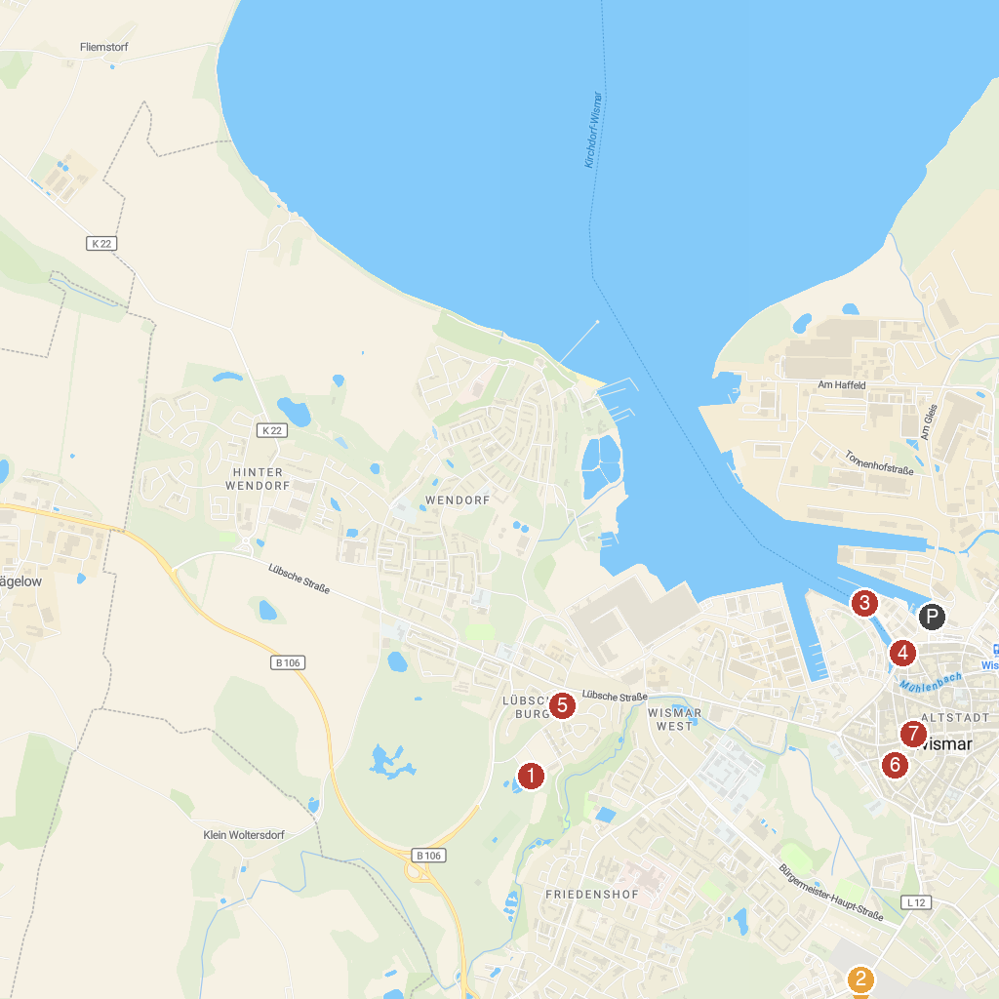
MAP KEY
1. Bürgerpark Wismar | 5. Wassertor
2. Kreisagrarmuseum Dorf Mecklenburg | 6. phanTECHNIKUM - Technisches Landesmuseum MV
3. Baumhaus Förderverein Poeler Kogge e.V. | 7. St. George's Church with viewing platform
4. Memorial Cap Arcona | 8. Welt-Erbe-Haus
P. Cruise port / terminal
Map © MapTiler © OpenStreetMap contributors · cruiseports.org

