Woody Point, Newfoundland, Canada
A historic outport inside a UNESCO World Heritage park, where the Earth's ancient mantle breaks the surface and Bonne Bay reflects the mountains. Woody Point punches far above its size.
⚓ Tender port (no pier) · 🕒 Typical call: 6-8 hrs · 💵 Canadian Dollar (CAD) · 🗣️ English · 🏔️ UNESCO World Heritage Site
✍️ MY DAY IN PORT (FILL IN)
Ship / Date
In port | arrive ______ · all aboard ______
Booked excursion
Notes / meeting point
GETTING ASHORE
- Docking: Tender — ships anchor in Bonne Bay; tenders land at Woody Point Waterfront Wharf
- Walk to centre: You step off the tender directly into historic downtown
- Best For: Geology fans, hikers, and anyone who loves authentic Newfoundland outport culture
- Don't Miss: The Tablelands — walk on the exposed Earth's mantle, a rare geological wonder
GETTING AROUND
- 🚕 Taxi: CAD $10/person each way — BonTours runs a passenger water taxi (the Bonne Bay Breeze) across Bonne Bay to Norris Point. Scenic and much faster tha
TOP THINGS TO DO
- The Tablelands Walk — One of the rarest geological sites on Earth — a barren, rust-orange landscape where 500-million-year-old mantle rock was thrust…
- Bonne Bay Boat Tour — Zodiac or covered-boat tours of Bonne Bay reveal the Tablelands from the water, Gros Morne Mountain, coastal communities, and…
- Gros Morne Discovery Centre — Parks Canada's world-class interpretive centre perched on the hillside above town, with immersive exhibits on the park's geology…
- Lookout Trail Hike — A moderate 5.8 km circuit above Woody Point offering some of the best panoramic views in the park — Bonne Bay, the Tablelands…
- Historic Waterfront Walking Tour — Woody Point's registered Heritage District lines Water Street — Victorian merchant buildings, colorful saltbox homes, the 1919…
BEST WALKS
- Waterfront Heritage Walk: 1.5 km · 30 min · Flat · Free — From the tender wharf, stroll Water Street past 19th-century merchant buildings, colorful homes…
- Up to the Discovery Centre: 1.6 km · 20-25 min · Steep uphill · Park pass required — A short but steep climb from downtown up to the Gros Morne National Park Discovery Centre.
WEATHER · DAYLIGHT · MONEY
Month | High °F | Low °F | Rainy days
May | 48 | 33 | 14
Jul | 68 | 53 | 16
Sep | 59 | 47 | 16
Daylight: May 5:37AM–8:59PM · Jul 5:32AM–9:22PM · Sep 6:58AM–7:34PM
cruiseports.org/woody-point-nl · Confirm terminal & all-aboard time with your ship

Woody Point, Newfoundland, Canada — Port Map
Red = walkable sights · Amber = excursions farther out · P = cruise terminal
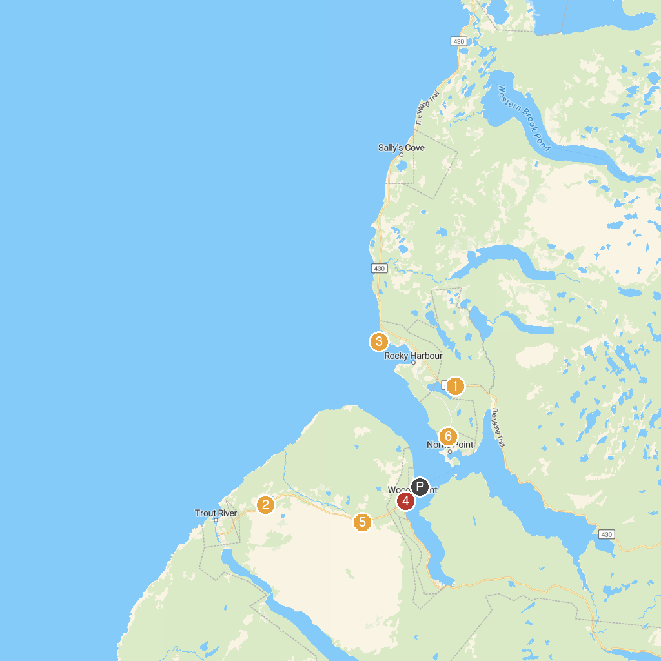
MAP KEY
1. Gros Morne National Park Visitor Centre | 5. Tablelands Trail
2. Green Gardens Trail | 6. Jenniex House
3. Lobster Cove Head Lighthouse | 7. Eastern Point Trail
4. Lookout Hills Trail
P. Cruise port / terminal
Map © MapTiler © OpenStreetMap contributors · cruiseports.org

