Wrangell, Alaska, USA
One of Alaska's oldest and least-touristy ports, Wrangell punches well above its size: ancient petroglyphs at low tide, a living Tlingit tribal house, kid-sold garnets at the dock, and the chance to see brown bears fishing in a forested canyon.
⚓ Docked (city pier) · 🕒 Typical call: 7-9 hrs · 💵 USD · 🗣️ English · 🐻 Wildlife-forward
✍️ MY DAY IN PORT (FILL IN)
Ship / Date
In port | arrive ______ · all aboard ______
Booked excursion
Notes / meeting point
GETTING ASHORE
- Docking: Ships tie up at Wrangell City Dock — steps from downtown, no tender
- Walk to center: 2 min on foot from dock to Front Street shops
- Best For: Authentic Alaska: petroglyphs, tribal culture, bears, river wilderness
- Don't Miss: Petroglyph Beach at low tide and the garnets at the dock
GETTING AROUND
- 🚕 Taxi: $10–$15 — Lady Driver Taxi and Xóots Taxi serve the area. Taxis are limited in number; booking in advance is recommended, especial
- 📱 Rideshare: ❌ not available
TOP THINGS TO DO
- Anan Wildlife Observatory — One of Alaska's premier bear-viewing spots, where black and brown bears congregate to feed on pink salmon in a forested creek…
- Stikine River Jet Boat — The Stikine is one of North America's fastest free-flowing rivers.
- Petroglyph Beach — Over 40 ancient rock carvings — some 8,000 years old — are carved directly into boulders on a public beach accessible at low tide.
- Chief Shakes Island & Tribal House — A small island in the harbor connected by a footbridge, home to a reconstructed Tlingit clan house and a collection of totem poles.
- LeConte Glacier Boat Tour — LeConte is the southernmost tidewater glacier in North America.
BEST WALKS
- Downtown Heritage Loop: 1.5 miles · 45 min · Easy — From the city dock, walk along Front Street past local shops to Chief Shakes Island for totem poles…
- Petroglyph Beach Walk: 2 miles one-way · 45 min each way · Easy (flat road) — Head north along Evergreen Avenue from downtown to Petroglyph Beach State Historic Site.
WEATHER · DAYLIGHT · MONEY
Month | High °F | Low °F | Rainy days
May | 57 | 43 | 16
Jul | 65 | 54 | 19
Sep | 59 | 48 | 19
Daylight: May 4:33AM–8:59PM · Jul 4:22AM–9:27PM · Sep 6:22AM–7:05PM
cruiseports.org/wrangell · Confirm terminal & all-aboard time with your ship

Wrangell, Alaska, USA — Port Map
Red = walkable sights · Amber = excursions farther out · P = cruise terminal
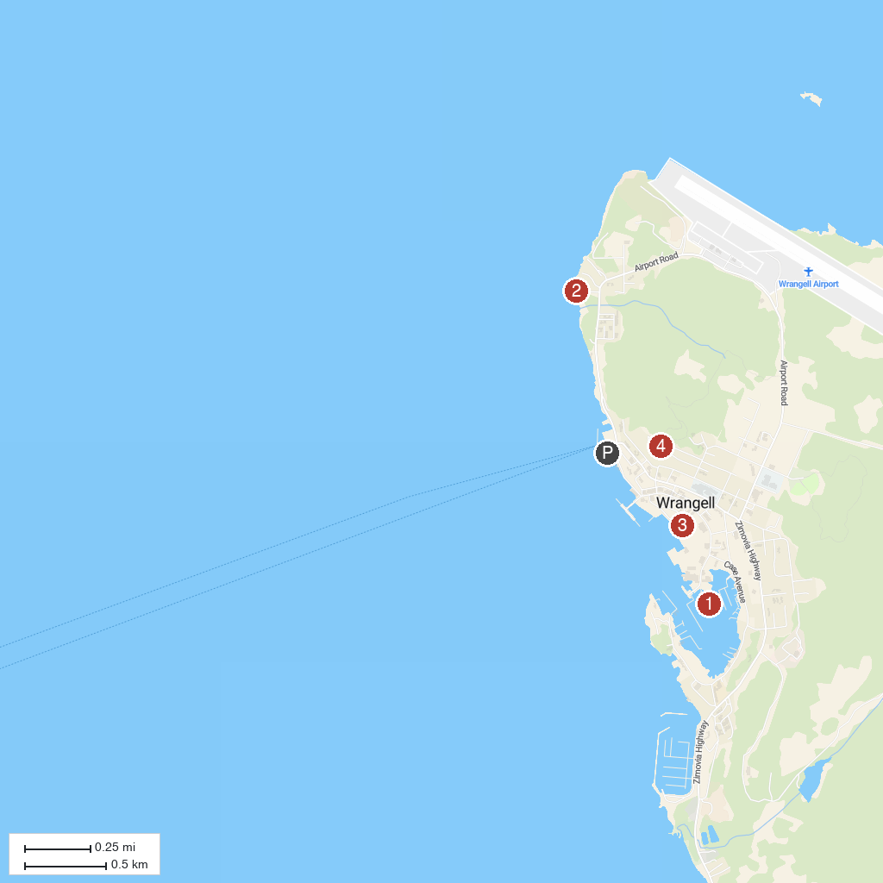
MAP KEY
1. Chief Shakes Tribal House | 4. Shakes Glacier
2. Petroglyph Beach State Historic Park | 5. Mount Dewey Trail
3. Wrangell Museum
P. Cruise port / terminal
Map © MapTiler © OpenStreetMap contributors · cruiseports.org

