Yokohama, Kanagawa, Japan
Japan's great port city hands you Chinatown on a 10-minute walk and Tokyo on a 40-minute train ride — with a futuristic waterfront in between.
⚓ Docked (pier) · 🕒 Typical call: 8-10 hrs · 💴 Japanese Yen (JPY) · 🗣️ Japanese
✍️ MY DAY IN PORT (FILL IN)
Ship / Date
In port | arrive ______ · all aboard ______
Booked excursion
Notes / meeting point
GETTING ASHORE
- Docking: Osanbashi or Shinko pier — no tender required
- Walk to center: Chinatown ~10 min on foot from Osanbashi; Minato Mirai ~20 min
- Best For: Culture, food, Tokyo day trips, modern Japan
- Don't Miss: Yokohama Chinatown, Red Brick Warehouse, Landmark Tower Sky Garden
GETTING AROUND
- 🚕 Taxi: ¥2,500–3,100 to Yokohama Station — Taxis queue at the terminal. ~5 min to Yokohama Station. Drivers rarely speak English — have your destination written in
- 📱 Rideshare: ✅ Uber Taxi, GO, DiDi
- 🚌 Hop-on hop-off: ✅ Akai Kutsu (Red Shoes) Loop Bus · from ¥600 day pass
TOP THINGS TO DO
- Yokohama Chinatown & Yamashita Park — Japan's largest Chinatown is a 10-minute walk from Osanbashi — 600+ restaurants and shops packed into a few vivid blocks.
- Minato Mirai & Landmark Tower — The futuristic Minato Mirai waterfront district clusters the 296m Landmark Tower (Sky Garden observation deck on floor 69), Cosmo…
- Day Trip to Kamakura — The Great Buddha of Kotoku-in stands 13.35 m tall in the open air — one of Japan's most iconic images.
- Tokyo Day Trip — Shibuya Crossing, Asakusa's Senso-ji temple, Meiji Shrine, and Ginza shopping — Tokyo is 30-45 minutes by direct train.
- Hakone & Mount Fuji Views — On a clear day, Hakone's open-air museum, Lake Ashi ropeway, and Fuji views make a spectacular excursion.
BEST WALKS
- Waterfront Promenade: Osanbashi to Minato Mirai: ~3 km | 45-60 min | Flat & easy — Leave Osanbashi terminal and walk west along the harbor past Yamashita Park, through the Shinko…
- Chinatown & Motomachi Stroll: ~2 km loop | 1-2 hrs | Easy — From Osanbashi, head inland 10 minutes to Yokohama Chinatown — Japan's largest, with 600+ eateries.
WEATHER · DAYLIGHT · MONEY
Month | High °F | Low °F | Rainy days
May | 71 | 59 | 11
Jul | 83 | 73 | 15
Sep | 79 | 70 | 15
Daylight: May 4:37AM–6:38PM · Jul 4:37AM–6:56PM · Sep 5:24AM–5:48PM
cruiseports.org/yokohama · Confirm terminal & all-aboard time with your ship

Yokohama, Kanagawa, Japan — Port Map
Red = walkable sights · Amber = excursions farther out · P = cruise terminal
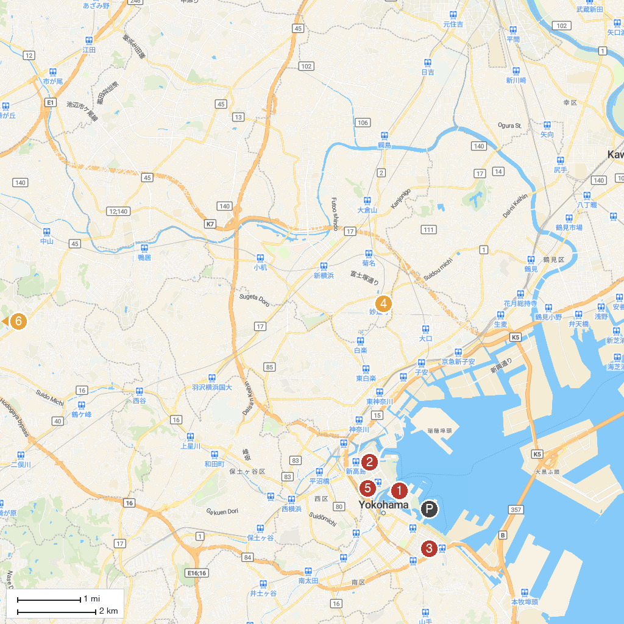
MAP KEY
1. CupNoodles Museum | 5. Asaina Kiridoshi
2. Takashima Chuo Park | 6. Kanazawa Zoological Gardens
3. Yamashitacho Park | 7. Mitsubishi Minatomirai Industrial Museum
4. Chōkōzan Myōrenji | 8. Zoorasia Yokohama Zoological Gardens
P. Cruise port / terminal
Map © MapTiler © OpenStreetMap contributors · cruiseports.org

