Ystad, Skåne, Sweden
One of Sweden's most charming port calls — medieval cobblestones, 300 half-timbered houses, and a short walk to everything. Ale's Stenar, Sweden's answer to Stonehenge, waits just 15 km away.
⚓ Pier (South Quay / Berth 7) · 🕒 Typical call: 6–8 hrs · 💳 Cashless — card everywhere (SEK) · 🗣️ Swedish (English widely spoken) · 🎬 Nordic Noir: Wallander filming location
✍️ MY DAY IN PORT (FILL IN)
Ship / Date
In port | arrive ______ · all aboard ______
Booked excursion
Notes / meeting point
GETTING ASHORE
- Docking: Pier (South Quay, Berth 7) — no tendering
- Walk to Center: ~10 min (600 m) via harbor path or free shuttle to station
- Best For: Medieval old town, Ales Stenar megalith, Wallander fans
- Don't Miss: Ales Stenar cliff-top stone ship, Per Helsas Gård courtyard
GETTING AROUND
- 🚕 Taxi: ~150–170 SEK — Taxis are available at the port and take just 2–3 minutes to the city center. Base fare is ~47.5 SEK plus ~24.3 SEK/km.
- 📱 Rideshare: ✅ Uber
TOP THINGS TO DO
- Ales Stenar — Sweden's Stonehenge — Fifty-nine massive boulders arranged in the shape of a ship on a windswept cliff above the Baltic Sea, built around 600 AD.
- Wallander's Ystad — Follow Kurt Wallander through real filming locations — his apartment on Mariagatan, the police station, and his favourite café.
- Ystad Abbey (Klostret i Ystad) — One of the best-preserved medieval monastery complexes in Sweden, founded by Franciscan friars in 1267.
- Ystad Studios Film Museum — One of the largest film museums in Sweden, housing original sets, props, and interactive exhibits from Wallander and the Nordic…
- Ystad Sandskog Beach — A 4 km stretch of white sand backed by pine forest just east of the port — easily walkable in 25 minutes.
BEST WALKS
- Old Town Stroll: 1.5 km · 45–60 min · Easy — Wander from the main square through Ystad's medieval lanes, past 300 half-timbered houses, St…
- Port to Sandskog Beach Path: 2.5 km · 25–30 min · Flat — A paved seaside path runs east from the harbor directly to the Ystad Sandskog pine-backed white…
WEATHER · DAYLIGHT · MONEY
Month | High °F | Low °F | Rainy days
May | 59 | 46 | 9
Jul | 70 | 58 | 12
Sep | 64 | 54 | 10
Daylight: May 4:55AM–9:08PM · Jul 4:43AM–9:36PM · Sep 6:37AM–7:21PM
cruiseports.org/ystad · Confirm terminal & all-aboard time with your ship

Ystad, Skåne, Sweden — Port Map
Red = walkable sights · Amber = excursions farther out · P = cruise terminal
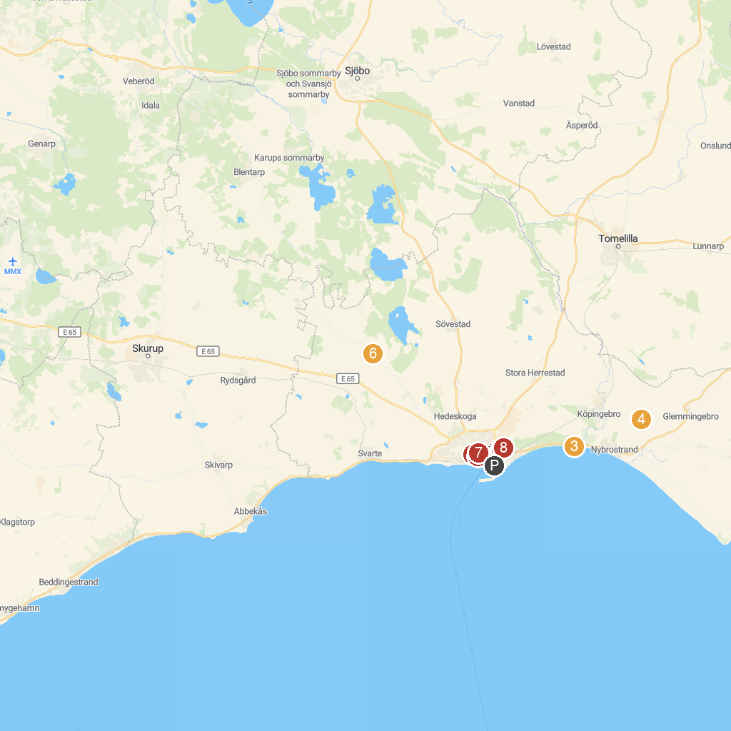
MAP KEY
1. Ystad's Military History Museum | 5. Sankta Maria kyrka
2. North Promenade | 6. Ystad Zoo
3. Nybroån | 7. Greyfriars Abbey, Ystad
4. Köpingsbergs vingård | 8. Ystad Studios Visitor Center
P. Cruise port / terminal
Map © MapTiler © OpenStreetMap contributors · cruiseports.org

