Zeebrugge, Belgium
Industrial Port Gateway to Medieval Flanders
Industrial Port · Bruges Gateway · North Sea Coast · Flemish Architecture
✍️ MY DAY IN PORT (FILL IN)
Ship / Date
In port | arrive ______ · all aboard ______
Booked excursion
Notes / meeting point
GETTING ASHORE
- Docking: Normally docked alongside at Swedish Quai — confirm your sailing’s berth and disembarkation instructions
- Currency: Euro (€)
- Language: Dutch (Flemish)
- Time Zone: CET (UTC+1)
GETTING AROUND
- 🚕 Taxi: €50–€75 one-way to Bruges — Taxis wait at the cruise terminal. A private cab to Bruges market square costs roughly €50 one-way; a minivan for up to
- 📱 Rideshare: ✅ Uber, Bolt
TOP THINGS TO DO
- Medieval Bruges City Center — Explore the Markt (Market Square) and the Belfry of Bruges, climbing the 366 steps for a panoramic view of the city.
- Canal Boat Tour of Bruges — A classic experience; glide through the serene canals of Bruges, often called the 'Venice of the North'.
- Damme and the Windmills — Visit the village of Damme, known for its historic windmills and peaceful countryside, located just outside Bruges.
- Ghent's Gravensteen Castle — Travel to Ghent to visit the Gravensteen (Castle of the Counts), a formidable medieval fortress with a moat and battlements.
BEST WALKS
- The Heart of Bruges Walk: Bruges City Center — Start at the Markt, walk through the Burg square, and visit the Basilica of the Holy Blood.
- The Lake of Love Walk: Lake of Love (Minnewater) — A romantic walk around Minnewater lake, followed by a stroll along the green City Ramparts park and…
- The Wall Walk: Bruges City Ramparts park — Follow the landscaped City Ramparts park paths around the historic city; this is a green park walk…
WEATHER · DAYLIGHT · MONEY
Month | High °F | Low °F | Rainy days
May | 61 | 49 | 11
Jul | 71 | 59 | 12
Sep | 67 | 55 | 11
Daylight: May 5:56AM–9:31PM · Jul 5:49AM–9:56PM · Sep 7:22AM–8:01PM
cruiseports.org/zeebrugge · Confirm terminal & all-aboard time with your ship

Zeebrugge, Belgium — Port Map
Red = walkable sights · Amber = excursions farther out · P = cruise terminal
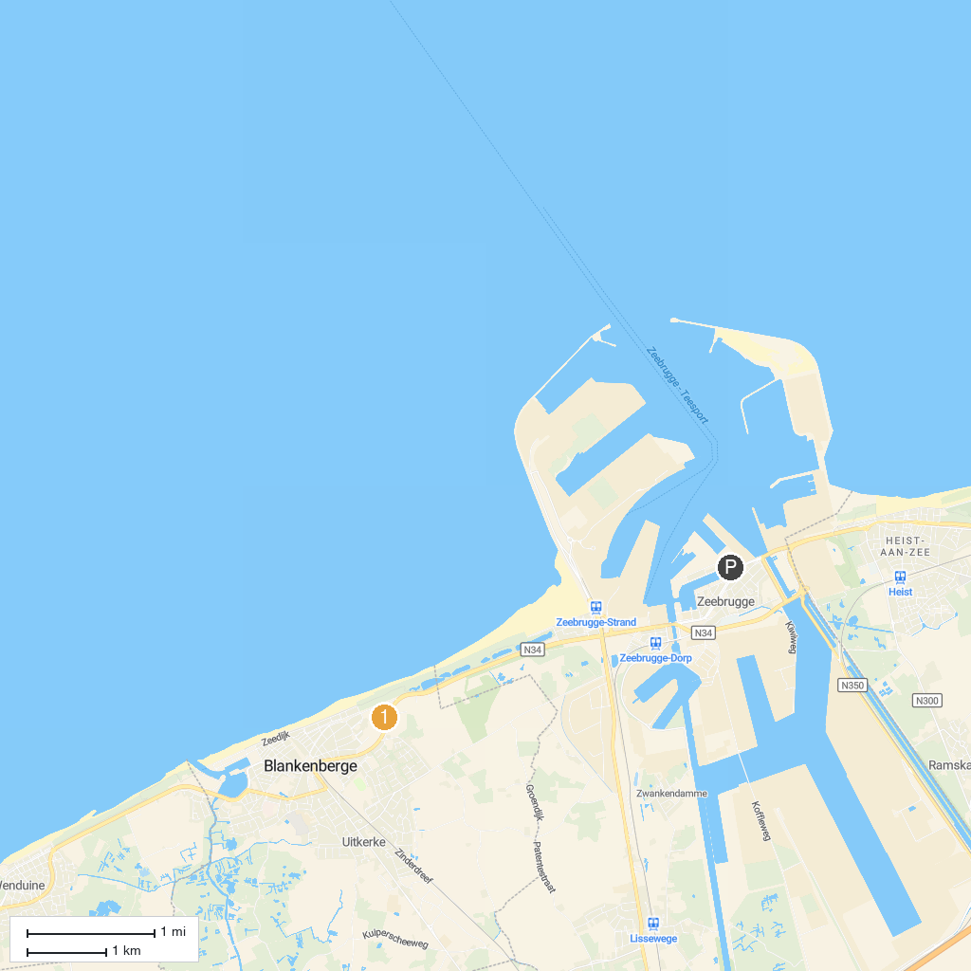
MAP KEY
1. Groeninge Museum | 4. Basilica of the Holy Blood
2. Choco-Story, Chocolate Museum | 5. Saint John’s Hospital
3. Belfry of Bruges | 6. SEA LIFE | Blankenberge
P. Cruise port / terminal
Map © MapTiler © OpenStreetMap contributors · cruiseports.org

